Pervasive Positioning Standard for Fingerprint-based and Proximity-based Systems

# Contents

Contents 1

Abstract 3

Introduction 4

1 Scope 5

2 Terminologies 6

3 Conventions 7

4 Motivation 7

5 Designs and Approaches 8

5.1 Operation Modes and Communication Protocols 8

5.2 Site Signal Data Organization, Retrieval and Format 15

5.3 Map Data Organization, Retrieval 17

6 Data Structures and Formats 19

6.1 Site Signal Data 20

6.2 Map Data 21

7 SDK API Specifications for Mobile Application Developers 23

7.1 Guideline for Implementing Pervasive Positioning 23

7.2 Detailed Specifications 26

7.2.1 Data Classes 26

7.2.2 API Manager 31

7.2.3 Localization Assistant 40

8 Server API Specifications for Site Owners 41

8.1 API URL 41

8.2 Mode 0 – APIs for Downloading Site Signals 42

8.3 Mode 1 – APIs for Computing Locations 45

9 Site Signal and Map Data Validation for Site Owners 46

9.1 Data package structure -- file system tree 46

9.2 Data file specification 47

10 User Journey Examples 53

10.1 Setting 53

10.2 Operation Mode 54

10.3 Switching Floor and Mode 61

10.4 Outdoor Localization 62

10.5 In-Outdoor Transition 62

Bibliography 62

Revision History 63

# Abstract

Pervasive positioning is to locate an object anywhere seamlessly on a country scale. Current positioning technologies are mature enough to support both indoor and outdoor environments, using site signal survey and indoor localization algorithms for indoor and GNSS for outdoor. Pervasive positioning can be realized provided that application requests location services from the correct parties using the correct formats. Pervasive Positioning Standard aims to bridge every party together. This standard specifies a set of communication protocols, data organization and format definitions for site signals, and data organization for maps using existing map standards. With this standard, existing location-based service (LBS) applications are able to operate anywhere in Hong Kong including their original supporting zone, and many novel LBS applications can be developed.

# Introduction

The goal of the Pervasive Positioning Standard is to enable any applications to locate their users anywhere so as to provide LBS potentially on a country scale. It is important to be able to locate users in both outdoor and indoor environments. In outdoor open areas, localization can be done with GNSS using satellite signals. In outdoor and indoor enclosed environments, we carry out site surveys and use the site signals to locate users. However, there are no agreed formats of site signals, so applications cannot share their site signals with others easily to enlarge their supported zone. In addition, pervasive positioning on a country scale requires the management of a huge size of site signal and map data. This standard aims to provide comm,unication protocols, data formats, and organization required for an application to locate a user anywhere efficiently.

This standard consists of three components: 1) A set of communication protocols, 2) data organization and format definitions for site signals, and 3) data organization for maps using existing map standards.

Pervasive Positioning Standard embraces existing standards, if possible, to avoid repeating definitions. The standards that are covered are: IMDF, IndoorGML, and a few image formats (JPEG, PNG, and GIF).

# 1 Scope

Pervasive Positioning Standard is a set of communication protocols with data organization designs on site signals and maps. It aims to help LBS applications get locations anywhere by requesting location services from the correct service providers. This standard defines:

* Communication protocols
  + SDK APIs for applications to request location service
  + Web APIs for site owners to host a server for service query
* Data organization and format definitions for site signals
  + A grid reference system for organizing site signals
  + Format definition of reference point for fingerprint-based system
  + Format definition of anchor of proximity-based system
* Data organization for maps
  + A multi-layered space model for organizing maps

This standard is for fingerprint-based and proximity-based localization only.

# 2 Terminologies

Data

Site signal data

Site signal data is collected from site survey. It is precomputed data that is used in indoor localization systems, for example, WIFI fingerprint, iBeacon location, etc. This standard is for fingerprint-based and proximity-based localization only.

Map data

Map data is used to display the environment, for example, a JPEG file, an IMDF archive, etc. This standard only supports image format, IMDF, and IndoorGML.

Site spatial data

Site signal and map data, collectively called site spatial data.

User signal

User signals are the surrounding sensor measurements of the user. The format is defined in this standard.

Stakeholders

End users (Applications)

Applications use this standard to provide pervasive positioning for end users. End users either upload user signals or download site signals according to their preference.

Site owners

Site owners are the data holders of the site spatial data in his/ her site(s). They either send site signals to the lookup server or host a server for location service query.

Site owners must upload map data to the lookup server.

Platform operator (Lookup server)

Lookup server is the contact point that applications connect for location services such as computing locations and transmitting site spatial data. It stores site signals and maps from site owners.

Developers

Application developers

Application developers who develop the LBS application using this standard to obtain locations.

Site owner’s developers

Developers who build and set up servers for site owners. According to whether site owners are willing to share site signals, site owners may or may not hire site owner’s developers to set up servers.

# 3 Conventions

Symbols and abbreviated terms

API Application Programming Interface

IndoorGML Indoor Geographic Markup Language

IMDF Indoor Mapping Data Format

JSON JavaScript Object Notation

JWT JSON Web Token

LBS Location-based Service

MLSM Multi-Layered Space Model

NRG Node-Relation Graph

n-D n-Dimensional

RSSI Received Signal Strength Indication

SDK Software Development Kit

# 4 Motivation

Different applications have different methods to locate users in indoor environments, unlike GNSS for outdoor areas. Therefore, site signals are stored in different representations and styles. Let us consider when computing locations across two buildings A and B. Suppose building A uses WIFI fingerprints as site signals and JPEG images as maps, while building B uses iBeacon proximity and IMDF files. The current solution is to build two different applications, so that when you need a location, you open application A to locate yourself in building A and application B in building B. This case illustrates the inconvenience and redundancy to get a location pervasively at this moment, and it is far from the concept of pervasive positioning – to locate users in any applications.

But surprisingly, pervasive positioning can be realized with a simple concept: applications contact the right parties using the right formats. Continuing with the example, suppose building A supports edge computation only and building B supports cloud computation only. Contacting the right party means contacting the server for downloading building A’s WIFI fingerprint as well as the server for computing locations in building B. Using the right formats means the data formats involved when contacting, for example, the WIFI fingerprint, user signal, location, etc.

Only two stakeholders, end users (applications) and site owners, involved in the communication cannot ensure that applications contact the right parties. In the first place, which building should be contacted when the application wants a location? Therefore, it is necessary to maintain a platform for retrieving the building location information and other useful data including metadata of site signals, maps that are needed to display the locations to users, etc.

Therefore, in order to bridge every stakeholder together to achieve pervasive positioning, this standard defines a set of communication protocols for applications, site owners and a lookup server (platform) as well as the spatial data formats and organization for running on a country scale.

# 5 Designs and Approaches

## 5.1 Operation Modes and Communication Protocols

Overview

Communication protocols describe the necessary components for applications to acquire locations, that is, what should be done for all stakeholders. The following diagram shows a general workflow of the protocols:

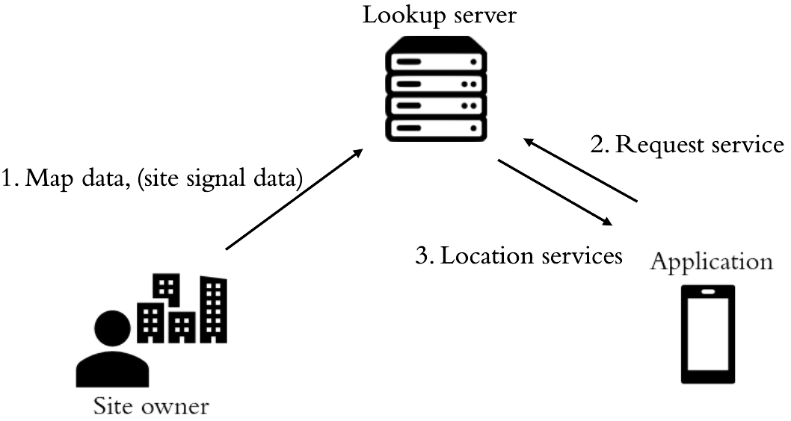

Figure 1. A general workflow of communication protocols

Site owners first upload map data and/or site signal data to lookup server. When applications request locations, they contact the lookup server, and the lookup server offers the location service to them, for example, sending nearby site signals to them or redirecting them to site owner’s server.

Four Operation Modes

End users and site owners may or may not want to share their data, which implies that only one operation mode is not enough. For example, a cloud approach is not applicable if end users do not share their user signals. Therefore, the communication protocols categorize all cases into four operation modes:

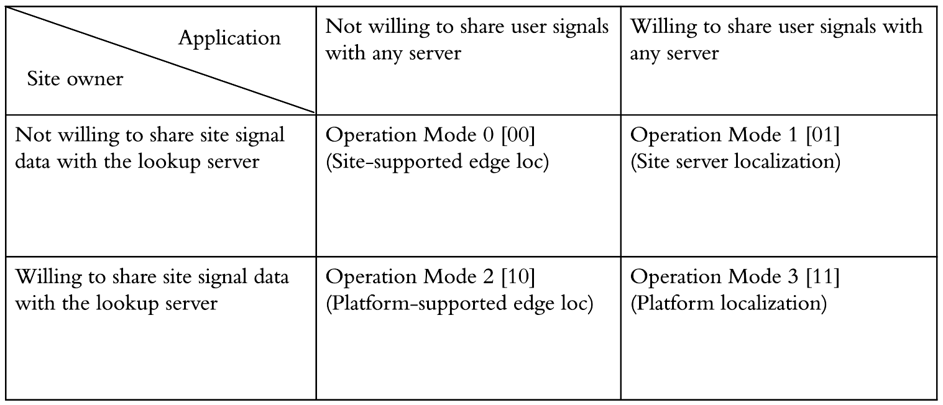

Table 1. Four operation modes for different pairs of applications and site owners

Applications may or may not want to share end users’ signal with any servers. This determines whether the operation mode is a cloud approach or an edge approach, since an edge approach must be chosen if applications do not share user. Besides, site owners also decide whether or not to share their site signals with the lookup server, determining if it is a centralized approach or a distributed approach. Therefore, depending on the types of applications and site owners, there are four operation modes.

The first bit of the binary form of the operation mode is whether the site owner is willing to share site signals with the lookup server while the second bit is whether the application is willing to share user signals with any server.

Operation mode 0 – Site-supported edge localization

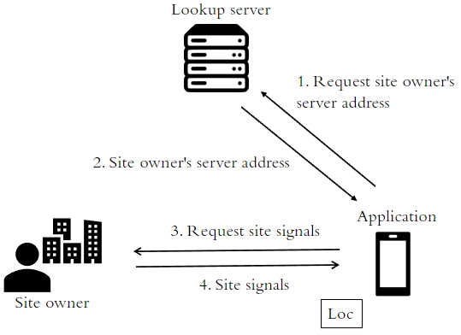

Figure 2. Operation mode 0

If the site owner does not share site signals with the lookup server and the application does not share user signals with any parties, they should choose operation mode 0. The site owner has to host a server for retrieving location and tell the lookup server his/her server address. Then the lookup server returns the server address upon the application’s request, redirecting it to the site owner’s server. After that, the application requests the site owner’s site signals and computes the location locally.

Operation mode 1 – Site server localization

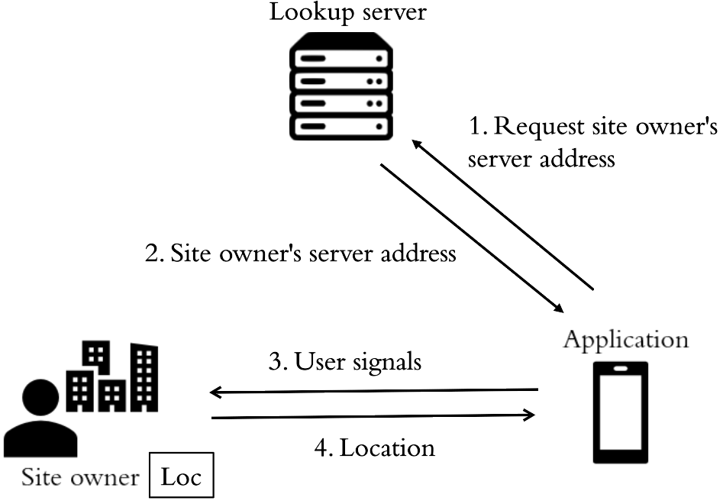

Figure 3. Operation mode 1

If the site owner does not share site signals with any parties but the application shares user signals, they should choose operation mode 1. This mode is similar to mode 0, but after the application is redirected, it sends user signals to the site owner’s server and receives the location.

Operation mode 2 – Platform-supported edge localization

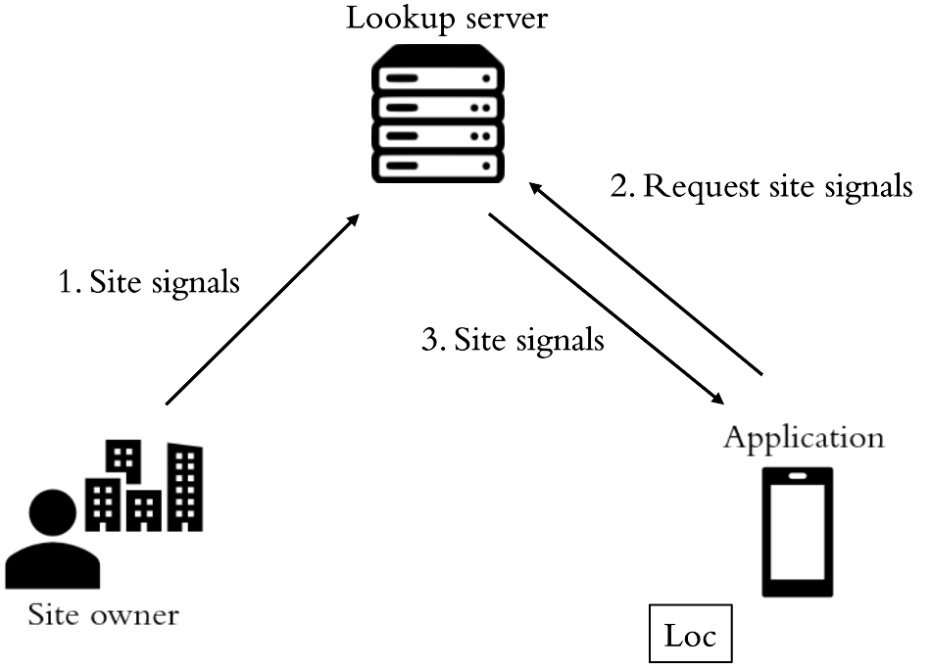

Figure 4. Operation mode 2

If the site owner shares site signals but the application does not share user signals, operation mode 2 is the best choice. In this mode, the site owner uploads his/her site signals to the lookup server. Then the application requests site signals from lookup server and computes location locally.

Operation mode 3 – Platform localization

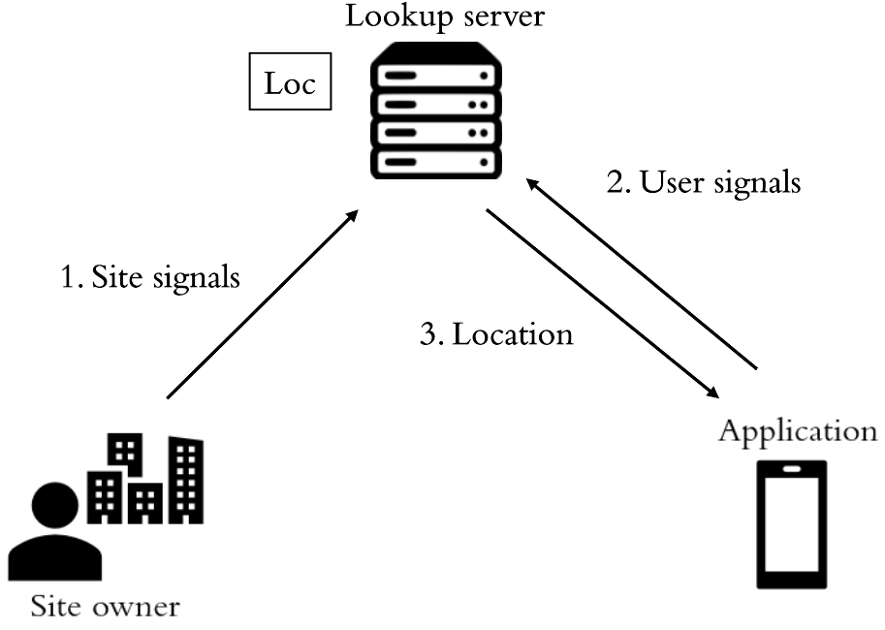

Figure 2. Operation mode 3

If both the application and the site owner are willing to share their data, operation mode 3 is the best choice. In this mode, the site owner uploads his/her site signals to the lookup server. Then the lookup server computes the location for the application upon its request.

Whether or not to share data with others

For applications, sharing user signals weakens end users’ location privacy and increases the latency since user signals will be uploaded to site owner’s server to compute locations. However, if applications do not share user signals, it must compute the location locally, which increases the device computational and storage requirements.

For site owners, there are three levels of sharing. The first is not to share with any parties. Site owners should choose operation mode 1 so as to avoid any data privacy concerns. The second is to share with application only, potentially restricting the number of people accessing their site signals. Then they should choose mode 0. The third is to share with anyone, choosing mode 2 or 3.

However, there is a tradeoff between privacy protection and cost since higher privacy protection means keeping more computation and information on their sides. Applications and site owners should choose the operation mode according to their preferences.

Handshaking for Choosing Operation Mode

It is important to provide the information needed for applications to choose the operation modes with the nearby building. Different applications may have different searching criteria and considerations. Therefore, a handshaking process is needed between applications and the lookup server to confirm the favored operation mode.

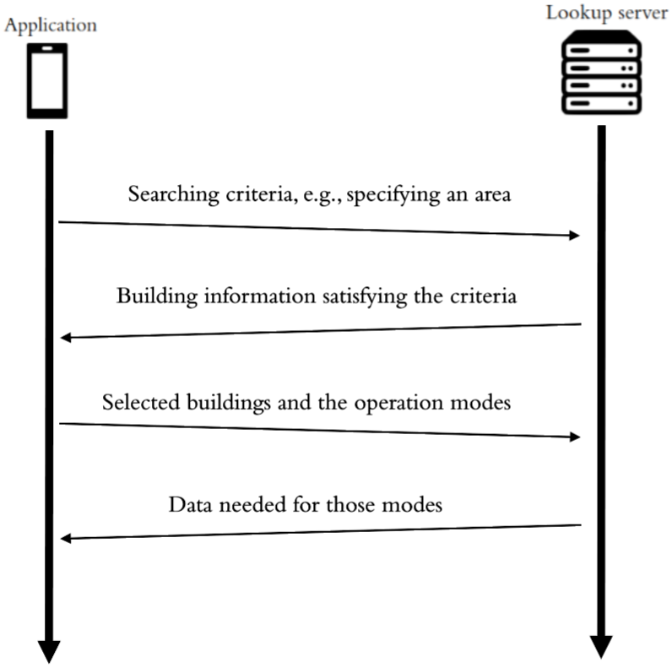

Figure 6. Handshaking between applications and the lookup server

The handshaking consists of four steps:

1. The application specifies a (set of) searching criteria that it is interested in, for example, specifying a circle by a center and a radius, filtering out buildings not having WIFI fingerprints, etc.
2. The lookup server returns building information satisfying the criteria. This information includes everything the application needs to decide whether or not to select the operation mode for this building, for example, the supported operation modes, type of supported site signals, etc.
3. The application returns the selected building(s) and the operation mode(s).
4. After confirming the operation mode and the building, the lookup server sends the necessary data for operation to the application. For example, the application needs the site owner’s server address to upload user signals for locations in operation mode 1.

Building Switching

Unlike traditional localization, pervasive positioning supports dynamically changing of the supported area. Therefore, before computing the location, an in-building region detection is carried out to ensure the application is inside the supported region. If the application is outside the supported region, the application needs to download the latest nearby site signals or connect to the site owner’s server of the newly arrived building, which is called building switching.

The simplest way is to handshake again with the lookup server to obtain the latest data for operation. Applications are suggested to include the previous building identity in the searching criteria in step one when handshaking, which improves efficiency and accuracy of the newly arrived building.

Obtaining Map Data

After computing or receiving the locations, applications need a map to display the location. Since every map data is stored in the lookup server, the application can request the map data from the lookup server using the computed location. Other map retravel methods are introduced in section 5.3.

Site Owners’ Server

In mode 0 and 1, site owners do not share data with the lookup server so they should host their servers to deal with applications’ requests. Mode 0 site owners need to host a server for downloading their site signals while mode 1 site owners need to host a server for computing location. The server should implement a specific list of APIs following this standard so as to ensure that the application can call the desired APIs in different buildings. The API specifications are in section 8.

SDK for Applications

Applications need to contact many different servers to obtain the location services. If applications need to communicate with different parties via web APIs at a low level, it increases the developer’s workload significantly. To facilitate the development of the application, this standard defines an SDK for retrieving location service to reduce the workload of application developers. Applications can handshake, download the site signals, connect to site owner’s servers, download map data via a set of APIs in the SDK. The SDK guidelines and API specifications are in section 7.

A Holistic View of Communication Protocols

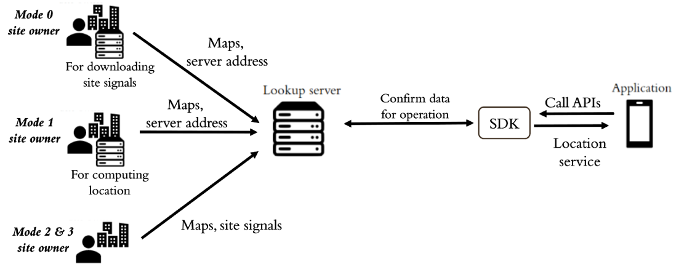

Figure 7. A holistic view of communication protocols

Before offering any location service, operation mode 2 and 3 site owners upload their site signals maps to the lookup server, while operation mode 0 and 1 site owners only upload maps to the lookup server, following the formats and procedures motioned in later sections. Additional works for mode 0 and 1 site owners is that mode 0 site owners host a server for querying their site signals and mode 1 site owners host a server for computing location. Then both of them send the server address to the lookup server.

The trigger point of a location service is when an application calls the SDK for location services. The SDK then contacts the lookup server to handshake to confirm data for operation, including the operation mode, the server address for uploading user signals as well as for requesting locations, the server address for downloading site signals, etc. After that, the SDK processes the data and provides the location services to the application.

Application Authentication and Authorization

As site owners may not want any application to access their server directly in mode 0 and 1, some authentication techniques are needed to ensure the call is from the standard SDK and the application is authorized. In this standard, JSON Web Token (JWT) [15] is used to provide both the authentication and authorization of each function call to the site owner’s server due to its simplicity and cross-domain functionality. A JWT, issued by the lookup server, is attached in each function call, so site owners can authenticate the user.

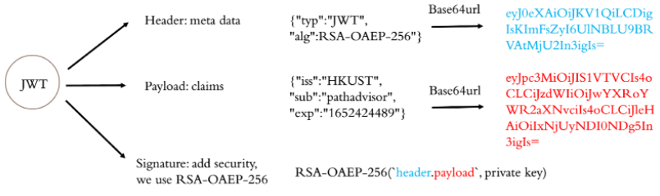Figure 8. Structure of a JWT in this standard.

Each JWT contains the information of the issuer, the subject and expiration time, and it is digitally signed by the lookup server. Specifications of JWT claims can be found in section 8.

## 5.2 Site Signal Data Organization, Retrieval and Format

Overview

With communication protocols, applications can contact the right party to obtain the site signal and map data, but it is also important to know how to retrieve the data correctly and efficiently. That is, the data must follow an agreed data format so that every party can interpret the data correctly, and the data can be retrieved with flexibility to support efficient querying with a grid reference system.

Site Signal Formats

An agreed data format of site signals is needed to provide site signal data interoperability. Currently, there is no agreed data format of site signals so that site signals are represented in different measurements and styles by different organizations. For example, WIFI AP signal strength can be measured by RSSI, dBm or other units, and the WIFI fingerprints can be stored in a text file, a database, or other data storage systems. In this way, unless an organization shares its data formats, others cannot interpret their site signals correctly. Therefore, this standard defines the site signal data formats for WIFI fingerprint-based and proximity-based systems:

Site signals for fingerprint-based systems are stored as reference points.

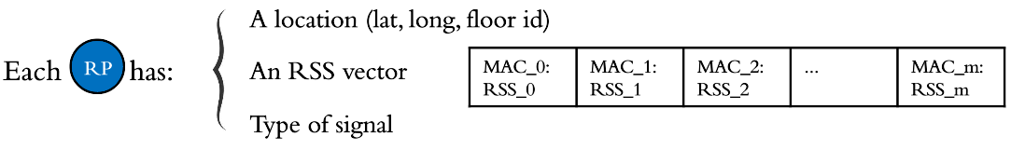

Figure 9. The structure of a reference point

In a fingerprint-based system, site signals are the fingerprints that comprise reference points. A reference point (RP) contains a location and a Received Signal Strength Indication (RSSI) vector that is collected in this location. A location is represented as a latitude, a longitude and a floor Id that represents the vertical information of the location. The floor Id refers to the floor Id in map organization and is defined in section 5.3. A RSSI vector is a collection of the sensor's identifications and their strength measurement. It is stored as the MAC addresses of the sensors and the RSSI.

Site signals for proximity-based systems are stored as pairs of device Ids and locations.

In a proximity-based system, site signals are the locations of the sensors. Currently, this standard supports iBeacon only. Therefore, the beacon identification is stored as their UUID, major and minor, and the location is stored as a latitude, a longitude and a floor Id.

Grid Reference System

Inspired by Google map structure [8], a grid reference system is used as the data organization of site signals to support efficient querying. The major similarity of outdoor maps and site signals is that users tend to load a specific area initially and the adjacent later on. It is inefficient to load the site signals using the building as a unit, and a fine resolution using grids is the preferred way to load the site signals.

There are three enhancements to the grid reference system to adopt the nature of site signals:

1. The information of a grid is enriched since a grid does not only store a map and the coordinates. The types of supported site signals and the signal data are stored in the grid for site signals. Other location data structures, for example, the zoom level and grid length, remain unchanged.
2. Vertical information is also needed for site signals. This standard represents grids in 2.5-D. It is stored as the floor Id of the site signals. The floor Id refers to the floor Id in map organization and is defined in section 5.3.
3. Adjacency is not the only connection between grids for site signals. Since users can travel a long distance between grids, for example, via an elevator an escalator. They can bring users from one grid to another grid that is far away, and the site signals between the two distant grids may not be useful. For example, if a user travels from 6F to GF via an elevator, the fingerprints of other floors are unnecessary. Therefore, this connection information is stored in a node-relation graph while grids are the nodes and a relation represents the connection between two grids.

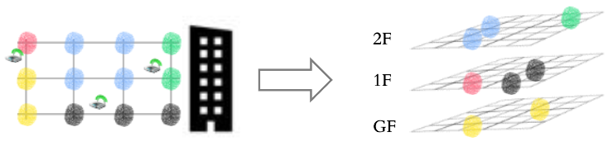

Figure 10. A grid reference system storing the site signals of a building

Site Signal Data Retrieval

Site signals are stored in site owner’s servers in operation mode 0 and 1 and in the lookup server in mode 2 and 3. They need to store the site signals in a grid reference system, following the data structure in section 6.1. With a common site signal data structure (in grids), applications can retrieve site signals flexibly and unambiguously in an edge approach. Grid is the basic unit of site signals, that is, applications retrieve data in grids from the lookup server and site owners' servers.

Site signals in the desired area can be retrieved by calling the predefined APIs. They provide data retrieval in a few different ways:

1. In a circle by specifying the center and the radius
2. In a rectangular region by specifying the maximum and minimum latitude and longitude
3. In a building by specifying the building Id, floor by floor Id and region by region Id
4. In the connected grids of a grid that is loaded previously

The resolution when retrieving the site signals is determined by the zoom level. The higher the zoom level, the finer grids will be retrieved. It is a tradeoff between efficiency and memory storage since if applications retrieve finer grids, they can have less memory occupied but they need to request more frequently when the users are moving.

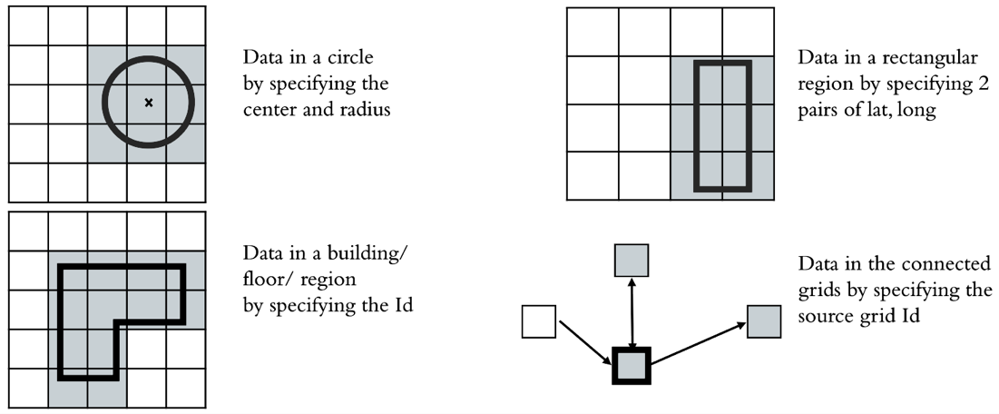

Figure 11. Different site signal data retrieval methods

The API specifications that the lookup server and site owners’ servers should follow are in section 8.

## 5.3 Map Data Organization, Retrieval

Overview

After applications compute or obtain a location, a map is needed for displaying the user location. Since every map data is uploaded to the lookup server. It is important to manage this large amount of data efficiently. In this standard, the lookup server stores the map data with a multi-layered space model while embracing existing map standards.

Existing Standards

Unlike site signals, there are a few mainstream indoor map standards. The following standards are supported:

1. Image formats including JPEG, PNG, and GIF. Images are well-known and common ways to store maps.
2. Indoor Mapping Data Format (IMDF) is another popular map standard recently. It provides a general yet comprehensive model for indoor map data. It supports efficient and mobile-friendly computations in edge devices. In addition, the model can be used not only in map displaying but also other location-based applications such as navigation, orientation, etc.
3. IndoorGML aims to provide comprehensive 3D indoor spaces modelling for navigation purposes. It is supported in this standard due to its potential usage in 3D LBS applications.

Multi-Layered Space Model

Inspired by IndoorGML [3], a multi-layered space model (MLSM) is used in order to manage complex indoor map data efficiently. A MLSM represents the same physical space in different representations. Each layer is the partitioning of spaces in one representation. In indoorGML, it is used to give the primal structure and different semantics, for example, primal space layer, topology space layer, WIFI coverage as a layer to record the spaces covered by each AP or a set of APs, etc. In this standard, the MLSM is designed in a way that suits our situation best.

There are two domains in the MLSM, namely primal space domain and map data domain. Primal space domain represents the building hierarchical and topological information while map data domain represents the details of the map data.

Primal space domain consists of three layers, namely building layer, floor layer and region layer. Inter-layer connections (ILCs) represent the hierarchical structure of the building. For example, an ITC between a building and a floor means the floor belongs to the building (the blue dotted lines in Fig. 10). Topological information is stored in the region layer for the finest resolution, shown as the gray lines in Fig. 10.

Map data also consists of three layers, namely map image layer, IMDF layer and IndoorGML layer. Each layer stores the data of its type and the attached space of the data. Each map data node contains the data that is necessary for display such as geodetic points and boundary. The ILCs between two domains are the attachment of map data and its primal space. For example, the indoorGML file in Fig. 10 is attached to the lower building, represented by the purple dotted line.

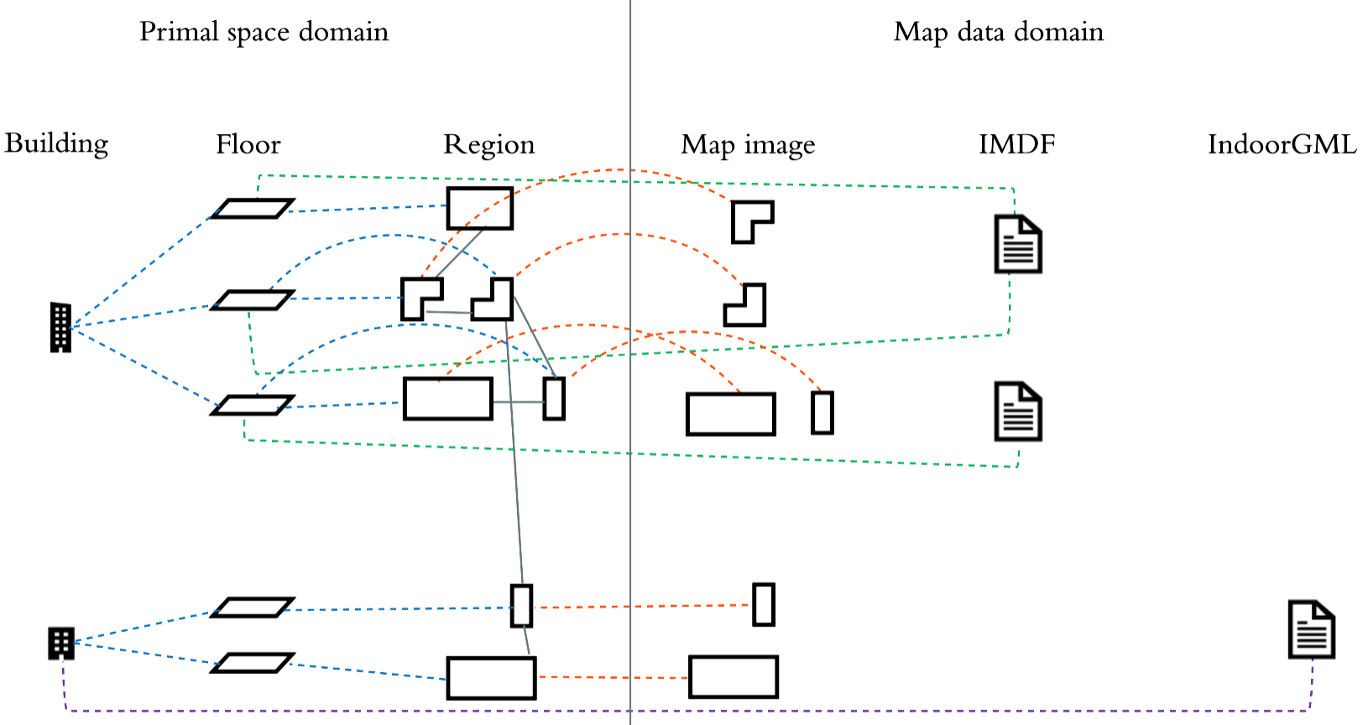

Figure 12. Multi-layered space model for managing map data

Site owners need to provide their maps, the hierarchical and topological information of their building to the lookup server, following the validation check in section 9. Then the MLSM in the lookup server will store them and will be used to deal with applications’ map requests.

Map Data Retrieval

With the MLSM, map data retrieval can be very flexible. There are three approaches to obtain maps:

1. By coordinates and constraints. Inputs specify a region, and the map data inside the region is returned. For example, given a location (latitude, longitude) and a radius, the map data inside that circle is returned.
2. By building, floor or region identity. Input is the Id of a specific building/ floor/ region, and the map data that is attached to this space and its children is returned. For example, given a floor Id, the map data of this floor and the child regions is returned.
3. By connections. Inputs are a source map Id and other requirements such as a direction, and the map data that is connected in the region layer is returned. For example, given a map Id, the map data that its attached space is connected to the attached space of the given map Id is returned.

More detailed descriptions and specifications are in section 7.

# 6 Data Structures and Formats

Every party has to follow the same data formats to store, send and receive site spatial data in order to ensure every party can retrieve and interpret the desired data correctly. In this standard, we define:

1. A set of site signal data format and a grid data structure for site signal organization
2. A multi-layered space model for map data organization

## 6.1 Site Signal Data

In this section, we first define a set of site signal data formats for different types of site signal, then we design a grid data structure to store site signals for efficient querying.

Site Signal Definition for Fingerprint-based System

In a fingerprint-based system, site signals are the fingerprints that comprise reference points with the measurements of surrounding sensors. A reference point defined as follows:

|  |  |  |
| --- | --- | --- |
| Attribute | Data type | Description |
| RP Id | UUID | The Id of the reference point |
| Latitude | Number | The latitude of the reference point in 6 decimal places |
| Longitude | Number | The longitude of the reference point in 6 decimal places |
| Floor Id | String | The floor Id of the reference point, referencing the Id in map data structure |
| WIFI RSS vector | Associative array | The WIFI RSS vector collected in the reference point. In each key-value pair, the key is the MAC address, and the value is the RSSI. It is null if the WIFI RSS vector is not supported. |
| BLE RSS vector | Associative array | The BLE RSS vector collected in the reference point. In each key-value pair, the key is the MAC address, and the value is the RSSI. It is null if the BLE RSS vector is not supported. |
| Magnetic signal | Array of number | An array of 3 elements that are the geomagnetic field strength along the x-, y-, and z-axis in μT |

<example to be filled out later>

Site Signal Definition for Proximity-based System

In a proximity-based system, site signals are the locations of the sensors. Each iBeacon is defined as follows:

|  |  |  |
| --- | --- | --- |
| Attribute | Data type | Description |
| Beacon Id | String | The Id of this iBeacon in this standard. The format is: UUID (in hex string form) concatenates with Major and Minor (in 5 digits) |
| Latitude | Number | The latitude of the beacon ‘s location in 6 decimal places |
| Longitude | Number | The longitude of the beacon’s location in 6 decimal places |
| Floor Id/Outdoor Site Id | String | In indoor environments, the floor Id should be given. It is the floor of the beacon’s location, referencing the Id in the map data structure  In outdoor environments, the site Id should be given, referencing to the site Id in section 9.3. It is the site that the beacon is in |
| UUID | Hex string | The UUID of the beacon in the form 8-4-4-4-12 |
| Major | Number | The major value of the beacon, ranging from 1 to 65535 |
| Minor | Number | The minor value of the beacon, ranging from 1 to 65535 |

<example to be filled out later>

Grid Reference System

Site signals are stored in a grid reference system for efficient retrieval of site signals. Each grid contains some site signals and topological information. A grid is defined as follows:

|  |  |  |
| --- | --- | --- |
| Attribute | Data type | Description |
| Grid Id | String | The Id of the grid. The format is the concatenation of zoom level, x-index, y-index and floor Id.  The Grid Id for indoor site will consist of 37 digits:  zoom level (2) + x-index (7) + y-index (7) + buildingId (19) + floor number (2).  The Grid Id for outdoor site will consist of 16 digits:  zoom level (2) + x-index (7) + y-index (7). |
| Zoom level | Number | The zoom level of the grid, ranging from 16 to 20 |
| X-index | Number | The x-index of the grid in this zoom level |
| Y-index | Number | The y-index of the grid in this zoom level |
| Floor Id | String | The floor Id of the beacon’s location, referencing the Id in map data structure.  It is empty for outdoor grids. |
| Connected grid Ids | Array | The array of connected grid Ids |
| RP Id list | Array | The array of RP Id that the reference points are in this grid |
| Beacon Id list | Array | The array of Beacon Id that the beacons are in this grid |

Zoom level describes the size of a grid

The higher zoom level, the grid is smaller. Each level n grid is composed of 4 level n+1 grids. At zoom level 0, there is only one grid representing the whole world. At zoom level 1, 2x2 grids cover the world. At zoom level 2, there are 4x4 grids, and so on.

X- and y-index are the column/row number of a grid

X-index is the column number counting in ascending order of longitude. Y-index is the row number counting in ascending order of latitude. Both indexes range from 0 to 2^ (zoom level)-1. The index is a 7-digit number.

Connected grid Ids are the grids that can be directly arrived from the current grid

For example, if an escalator is from grid A to grid B, then grid B’s Id is in grid A’s connected grid ids. If an elevator connects grids C, D, E, then they are in each other’s connected grid Ids.

Equations Connecting Latitude, Longitude, and Grid Reference System

Latitude ranges from –90 to 90 and relates to y-index. Longitude ranges from –180 to 180 and relates to x-index.

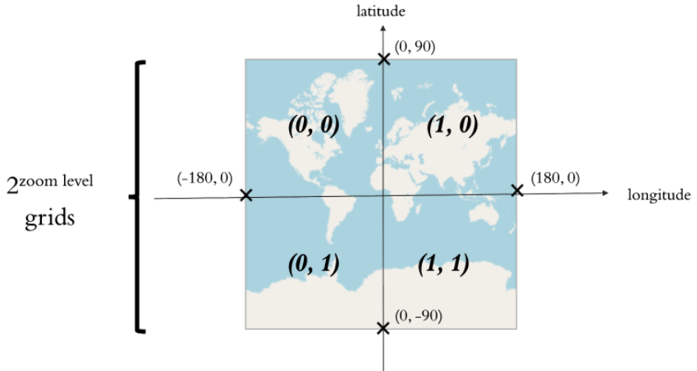  
Figure 13. Grids at zoom level 1.

This is the grids at zoom level 1. Besides the latitude and the longitude, the number of grids in a row or in a column is 2zoom level.

Computing corner coordinates of a grid given x-, y-index and the zoom level z

By geometry, we come up with 4 equations:

Computing x-, y-index given latitude and longitude at zoom level z

By geometry, we come up with 2 equations:

Computing x-, y-indexes of the next zoom level

A grid at zoom level z contains 4 grids at zoom level (z+1). Their indexes are: (2x, 2y), (2x, 2y+1), (2x+1, 2y), (2x+1, 2y+1)

## 6.2 Map Data

Recall that this standard does not define new map standards but embraces the existing map standards, such as images, IndoorGML, and IMDF, providing a multi-layered space model for flexible and efficient map data retrieval from applications.

A Multi-layered Space Model

There are two domains in this model, namely primal space domain and map data domain. The former describes the physical space hierarchical and topological information, while the latter describes the map data. Note that the connections (edges) are stored in the nodes like adjacency list. Therefore, nodes under each layer contain the layer as well as the connection information.

Primal space consists of three layers – building, floor, region

The building layer contains hierarchical information about the building. It is defined as follows:

|  |  |  |
| --- | --- | --- |
| Attribute | Data type | Description |
| Building Id | Hex string | The Building Common Spatial Unit Identifier (CSUID) of the building. Building CSUID consists of geo-reference number, polygon type and creation date.  Geo-reference number: a 10-digit identifier formed by combining the Easting and Northing of the building label point within the polygon.  (Easting and Northing are from HK 1980 Grid Coordinates, decimal is truncated and the first digit is removed from the coordinates.)  Polygon type: ‘T’ or ‘P’. T for Tower, P for Podium.  Creation Date: YYYYMMDD  e.g. BuildingId: “4520522021T20220412” |
| Name | String | The display name of the building |
| Child Ids | Array | The array of child floor Ids, referencing floor Id in the floor layer. It is sorted by elevation ascendingly. |
| Default floor Id | Hex string | The default floor of the building to be displayed |
| Data file Ids | Array | The array of data file Ids that are attached in the building, referencing the data file Id in map data domain |

The floor layer contains hierarchical information about the floor. It is defined as follows:

|  |  |  |
| --- | --- | --- |
| Attribute | Data type | Description |
| Floor Id | Hex string | Building Id concatenates with the floor number |
| Floor number | Hex string | An 8-bit hex string (2 letters) indicating the floor number. The first bit is 0 if it is above ground, 1 if lower ground. The remaining 7 bits are the magnitude of the floor. For example: 01 = 00000001(2) is the 1/F, and 14 = 10000100(2) is the LG 4/F  Remarks: 00000000 is G/F while 10000000 is invalid |
| Name | String | The display name of the floor excluding the building name. |
| Parent Id | Hex string | The parent building Id |
| Child Ids | Array | The array of region Ids, referencing region Id in the region later |
| Default region Id | Hex string | The default region of the floor to be displayed |
| Data file Ids | Array | The array of data file Ids that are attached in the building, referencing the data file Id in map data domain |

The region layer contains hierarchical and topological information about the region. It is defined as follows:

|  |  |  |
| --- | --- | --- |
| Attribute | Data type | Description |
| Region Id | Hex string | Floor Id concatenates with the region number |
| Region number | Hex string | An 8-bit hex string (2 letters) indicating the region number. |
| Name | String | The display name of the region excluding the floor name |
| Parent Id | Hex string | The parent floor Id |
| Data file Ids | Array | The array of data file Ids that are attached in the building, referencing the data file Id in map data domain |
| Connected regions | Associative array | This describes the transition regions and their arrival regions of this region in this form:  [transition region: [arrival region1, ...]]  A transition region is described as [minLon, minLat, maxLon, maxLat]  An arrival region is described as {regionId: id, area: [minLon, minLat, maxLon, maxLat]} |

Map data domain stores each type of map in one layer

Currently, this standard only supports image, IMDF and IndoorGML, and they are stored in the same structure. It is defined as follows:

|  |  |  |
| --- | --- | --- |
| Attribute | Data type | Description |
| Data Id | UUID | The Id of the map |
| Format | String | The format of the map, e.g., jpg, png, indoorgml, imdf, etc. |
| Geodetic points | Array | The array of geodetic points. Each geodetic point contains a coordinate in the map and a [lon,lat] pair. The array contains at least 2 geodetic points.  Both the latitude and longitude are in 6 decimal places. |
| Boundary | Array | The array of [lon,lat] of the boundary of the image |
| Attached primal space | Hex string | The attached primal space Id. It can be a building Id, floor Id and region Id. |
| Data | Byte | The data content of the image |

# 7 SDK API Specifications for Mobile Application Developers

This section is written for mobile developers who want to implement pervasive positioning in their apps. To start off, developers should read the “Guideline for implementing pervasive positioning” to get an overview of SDK usage and read the “Detail specification of SDK” to understand classes and API interface in SDK for your application development.

## 7.1 Guideline for Implementing Pervasive Positioning

Initialization Step

The first step of pervasive positioning is to initialize the Global Positioning System to get an initial location. This GPS result will help your application to start handshaking with the pervasive positioning platform in the following steps.

Next, detect whether the user is under an indoor or outdoor environment. You can either:

1. use d*etectIndoorEnviroment(lat,lon,accuracy)* in our Localization Assistant of SDK; or
2. implement your own indoor-outdoor environments detection algorithm.

This detection result will help your application to make decisions between using indoor positioning technology or using outdoor positioning technology.

Indoor Localization

If you want to implement indoor positioning, you should follow the steps below:

1. Detect which building you have entered
2. Decide whether to share user signals for localization
3. Get localization service from platform or site server
4. Compute or receive indoor location
5. Get map for display and navigation from platform
6. Check if the user entered switch zone periodically
7. Discover which building you have entered

This step helps you to discover the correct building from your GPS location or indoor location. Each building will have their own settings on providing indoor localization, some may share a variety of site signals, and some may only provide their own cloud localization service for users. Discover the building where your device is inside will help the SDK retrieve correct settings for your indoor localization.

Developers should call d*iscoverBuilding(latitude, longitude, accuracy)* in our API Manager of SDK. SDK will contact the platform to download building’s localization settings and cache them in API Manager for further usage. Remember to keep the return value of d*iscoverBuilding(latitude, longitude, accuracy)*, you will use it in the next step.

1. Decide whether to share user signals for localization

After you discover the current building, you will need to decide which localization approach you want to use in this building. Localization approach support by the current building is indicated by the returned string of d*iscoverBuilding(latitude, longitude, accuracy)*, “cloud”, “edge” or ”all_available”. Developer can adapt supported approach to get localization service.

This decision should be made according to your application’s security concerns. As adapting cloud approach requires you to share user signals with cloud server, it will reveal user’s location to the service provider. Developers who wish to keep high location security should priorities edge approach rather than cloud approach. During implementation, we recommend developers to implement your localization in a prioritize logic to support both edge localization and cloud localization. You can consider to only adapt one approach in your app, but remember you may not be able to support buildings who only support another approach.

No matter what approaches you choose, we must acquire an authentication token through *generateToken(appID,key)* first. This token will grant your access to location service provided by platform and site servers. If your appID and key is authorized by the platform, a token will be generated and keep in API Manager for getting location services.

If you decide to implement edge localization and try to get a site signal package, go to 3a. For implementation of cloud approach, go to 3b.

1. Get localization service from platform or site server
   1. Edge approach

This step helps you to initialize indoor edge localization in the current building. First, call g*etGridIDListForEdgeLoc()* API to get the gridID list by parameters. GridID list describes areas you want to download site signal. Then, call d*ownloadSiteSignal()* API to retrieve site signals data from the platform or site owner’s server.

* 1. Cloud approach

This step helps to you initialize indoor cloud localization in the current building. First, call g*etSignalTypeForCloudLoc()* API to get the required signal type of cloud localization algorithm. You will need to scan these types of signals for cloud localization. Then, call u*ploadSignalToCloud()* API to upload user ID and user signals to the platform or site owner’s server.

1. Compute or receive indoor location

For edge approach, you can use the return site signals from API in your indoor edge localization algorithm, and compute a user's location.

For cloud approach, you can call g*etCloudLocResult()* to download user location computed by cloud server.

1. Get map for display and navigation from platform

After you have gathered a user's location, you need to download a map to display the location on your application.c API to search all available maps for your location or desired floor. You should choose a mapID that matches your desired level of spatial representation and your displayable filetype. After you get your desired mapID and map filetype, use them in g*etMapFile(filetype,mapID*) to download actual map file. Remember to deserialize returned byte array to actual map file.

1. Detect switch condition periodically for switching localization services

In the indoor positioning, users may walk across multiple buildings or go to an outdoor environment. You will need to switch to indoor localization service of another building, or switch to outdoor localization service. Therefore, you have to implement a switch zone detect mechanism. SDK provided a reference design: d*etectSwitchCondition(location)* API. This API is used to check if your indoor location falls inside a switch zone to another building or the outdoor environment. If the user is going into another building, the API returns a Building ID. If the user is going to an outdoor environment, the API returns an “Outdoor” tag for indication.

If switch building condition is detected, you will need to handshake with another building and use their localization service. You may go back to step 1 of indoor localization, and find building settings with connected Building ID to start again. You will need to add connected = True in some API call to indicate you wants to get localization service of connected building, so that localization service from current building won’t be affect.

On the other hand, if switch outdoor condition is detected, you should switch to use outdoor localization service.

Outdoor localization

For outdoor localization, you can either use GPS results directly or implement your outdoor localization algorithm with outdoor signals.

If you want to get outdoor signals, such as Smart Lampposts, you should first call *discoverOutdoorSite(latitude,longitude,radius)* to find the correct outdoor site who have outdoor signals. Then call g*etOutdoorSignal(latitude,longitude,radius,siteSignalMode)* to get nearby outdoor signal information from the Pervasive Positioning Platform or Site owner server.

## 7.2 Detailed Specifications

SDK will be responsible for handling handshaking protocol and acquiring necessary information for pervasive localization from the platform.

SDK will consist of three parts:

|  |  |
| --- | --- |
| Data Classes | Classes for representing data in handshaking. Spatial representation, signal grids, raw signals, etc. |
| API Manager | Handling handshaking API calls, retrieving necessary data from platform database, returning Data class object to the caller |
| Localization Asistant | Reference design algorithms for pervasive localization (in-outdoor detection, switch condition detection) |

## 7.2.1 Data Classes

Classes for handling API response data, such as Building, Floor, Region in Spatial representation, Building Signal Object, Grid Object, raw signal and Location Object in site signal standard.

These data classes assist in the handshaking process and initialization of localization service, most of the API results will return as a Data class, so developers are recommended to use these classes for data handling as well.

For handshaking convenience, some of the data will be kept in the API Manager as current state information (BuildingID, GridID, connection information)

Data Classes for Spatial Representation

|  |  |  |
| --- | --- | --- |
| public abstract class **SpatialObj**  extends **Object** | | |
| Member | Type | Description |
| ID | String | ID of SpatialObj |
| name | String | Display name of SpatialObj |
| mapDataID | List<String> | ID of map file that represents this SpatialObj |
| connectedList | List<Connection> | A list of connections represents connection area towards other SpatialObj |

|  |  |  |  |
| --- | --- | --- | --- |
| public class **BuildingObj**  extends **SpatialObj** | | | |
| Inheritance | Member | Type | Description |
| Inherited member | ID | String | ID of building, CSUID of building |
| name | String | Display name of building |
| mapDataID | List<String> | ID of map file that represents this building |
| connectedList | List<Connection> | A list of connections represents connection area towards other BuildingObj |
|  | floorList | List<FloorObj> | A list of floors contained by this BuildingObj |
| defaultFloorID | String | ID of FloorObj that is located on ground level |

|  |  |  |  |
| --- | --- | --- | --- |
| public class **FloorObj**  extends **SpatialObj** | | | |
| Inheritance | Member | Type | Description |
| Inherited member | ID | String | ID of floor |
| name | String | Display name of floor |
| mapDataID | List<String> | ID of map file that represents this floor |
| connectedList | List<Connection> | A list of connections represents connection area towards other FloorObj |
|  | floorNo | String | An 8-bit hex string (2 letters) indicating the floor number.  Refer section 6.2 Map Data |
| regionList | List<RegionObj> | A list of RegionObj contained by this FloorObj |
| defaultRegionID | String | ID of RegionObj that acts as default region |

|  |  |  |  |
| --- | --- | --- | --- |
| public class **RegionObj**  extends **SpatialObj** | | | |
| Inheritance | Member | Type | Description |
| Inherited member | ID | String | ID of region |
| name | String | Display name of region |
| mapDataID | List<String> | ID of map file that represents this region |
| connectedList | List<Connection> | A list of connections represents connection area towards other RegionObj |

|  |  |  |
| --- | --- | --- |
| public class **MapObj**  extends **Object** | | |
| Member | Type | Description |
| ID | String | ID of map |
| mapType | String | Type of map, PNG/JPEG/IMDF/IndoorGML |
| geodetic | List<GeodeticPoint> | A list of geodetic points that represent projection of map coordinate system to WGS84 coordinate system |
| boundary | List<Point> | A list of (latitude, longitude) points representing boundary of map |
| attachedPrimalSpaceID | String | Spatial ID of building/floor/region represented by this map |
| filename | String | Filename of actual mapfile |
| fileContent | byte [] | Byte array of map file content |

Data Classes for Site Signal Standard

|  |  |  |
| --- | --- | --- |
| public class **BuildingLocSetting**  extends **Object** | | |
| Member | Type | Description |
| ID | String | ID of Building, same as BuildingObj |
| boundary | List<Point> | A list of (latitude, longitude) points representing boundary of map |
| operationMode | List<String> | A list of localization operation modes that are available in this building. Modes will be represented in [0,1,2,3] |
| siteSignalMode | List<String> | A list of site signals available in this building. |
| cloudLocSignalMode | List<String> | A list of user signals needed by the cloud localization service of this building |
| relatedGridList | List<String> | A list of Grid ID which related to this building |
| remoteSignalDownloadURL | URL | URL for download site signal from site owner’s server |
| remoteCloudLocUploadURL | URL | URL for uploading users’ signals (required by cloudLocSignal) to site owner’s cloud localization service |
| remoteCloudLocDownloadURL | URL | URL for download user location from site owner’s cloud localization service |

|  |  |  |
| --- | --- | --- |
| public class **GridObj**  extends **Object** | | |
| Member | Type | Description |
| ID | String | ID of Grid |
| boundary | List<Point> | A list of (latitude, longitude) points representing boundary of grid |
| connectedGridID | List<String> | A list of grid id which connected to current grid in one hop |

|  |  |  |
| --- | --- | --- |
| public abstract class **SignalObj**  extends **Object** | | |
| Member | Type | Description |
| ID | String | ID of SignalObj |
| coordinate | Point | Reference point of SignalObj in (latitude, longitude) |
| floorID | String | ID of FloorObj where this SignalObj locate at |

|  |  |  |  |
| --- | --- | --- | --- |
| public class **WiFiFingerprintObj**  extends **SignalObj** | | | |
| Inheritance | Member | Type | Description |
| inherited member | ID | String | ID of WiFiFingerprintObj |
| coordinate | Point | Reference point of WiFiFingerprintObj in (latitude, longitude) |
| floorID | String | ID of FloorObj where this WiFiFingerprintObj locate at |
|  | rssiVecList | List<Wifi> | A list of wifi rssi signal |

|  |  |  |  |
| --- | --- | --- | --- |
| public class **BLELocationObj**  extends **SignalObj** | | | |
| Inheritance | Member | Type | Description |
| inherited member | ID | String | ID of BLELocationObj |
| coordinate | Point | Reference point of BLELocationObj in (latitude, longitude) |
| floorID | String | ID of FloorObj where this BLELocationObj at |
|  | UUID | String | UUID of BLE device |
| major | String | Major of BLE device |
| minor | String | Minor of BLE device |
| txPower | Integer | Transmission power of BLE device |

|  |  |  |  |
| --- | --- | --- | --- |
| public class **MagFingerprintObj**  extends **SignalObj** | | | |
| Inheritance | Member | Type | Description |
| inherited member | ID | String | ID of MagFingerprintObj |
| coordinate | Point | Reference point of MagFingerprintObj in (latitude, longitude) |
| floorID | String | ID of FloorObj where this MagFingerprintObj locate at |
|  | magneticVecList | List<Magnetic> | A list of magnetic signal |

Data Class for Raw Signal

|  |  |  |
| --- | --- | --- |
| public class **WiFi**  extends **Object** | | |
| Member | Type | Description |
| mac | String | Mac address of received WiFi signal |
| rssi | Integer | Receive signal strength indicator in dBm |
| freq | Integer | Frequency of received WiFi signal |

|  |  |  |
| --- | --- | --- |
| public class **BLE**  extends **Object** | | |
| Member | Type | Description |
| UUID | String | UUID of received BLE signal |
| major | String | Major of received BLE signal |
| minor | String | Minor of received BLE signal |
| rssi | Integer | Receive signal strength indicator in dBm |
| txPower | Integer | Transmission power level received in BLE signal |

|  |  |  |
| --- | --- | --- |
| public class **Magnetic**  extends **Object** | | |
| Member | Type | Description |
| mag_x | Double | Magnetic field reading of x-axis |
| mag_y | Double | Magnetic field reading of y-axis |
| mag_z | Double | Magnetic field reading of z-axis |

Data Class for Coordinate Related Object & Point of Interest(PoI)

|  |  |  |
| --- | --- | --- |
| public class **Point**  extends **Object** | | |
| Member | Type | Description |
| lat | Double | Latitude of this point in WGS84 coordinate system |
| lon | Double | Longitude of this point in WGS84 coordinate system |

|  |  |  |  |
| --- | --- | --- | --- |
| public class **GeodeticPoint**  extends **Point** | | | |
| Inheritance | Member | Type | Description |
| inherited member | lat | Double | Latitude of this point in WGS84 coordinate system |
| lon | Double | Longitude of this point in WGS84 coordinate system |
|  | x | Double | x-axis coordinate of map coordinate system, which is different from WGS84 |
|  | y | Double | y-axis coordinate of map coordinate system, which is different from WGS84 |

|  |  |  |  |
| --- | --- | --- | --- |
| public class **Location**  extends **Point** | | | |
| Inheritance | Member | Type | Description |
| inherited member | lat | Double | Latitude of this point in WGS84 coordinate system |
| lon | Double | Longitude of this point in WGS84 coordinate system |
|  | floorID | String | ID of the Floor where this location is at |

|  |  |  |
| --- | --- | --- |
| public class **Connection**  extends **Object** | | |
| Member | Type | Description |
| transitionArea | List <Point> | Array of [lon,lat] points representing current transition area |
| arrivalAreaList | List < ArrivalArea> | Array of ArrivalArea representing all connected areas that connects to current transition area. |

|  |  |  |
| --- | --- | --- |
| public class **ArrivalArea**  extends **Object** | | |
| Member | Type | Description |
| arrivalArea | List <Point> | Array of [lon,lat] points representing connection arrival area |
| connectedID | String | SpatialObj ID or Grid ID of arrival area. |

## 7.2.2 API Manager

API Manager is a singleton class to provide API call interface for developers. For any needs to communicate with the platform to retrieve data for localization, the developer should call this API Manager for solutions.

API List

|  |
| --- |
| Constructor   1. APIManager getInstance() |
| Initialize handshaking   1. String discoverBuilding(double *latitude*, double *longitude*, double *accuracy*) 2. String discoverBuilding(String *connectedID*) 3. Boolean switchToConnectedBuilding() 4. Boolean generateToken(String appID, String key) |
| Indoor edge localization   1. List<String> getGridIDListForEdgeLoc(Boolean connected, double *latitude*, double *longitude*, double *radius*) 2. List<String> getGridIDListForEdgeLoc(Boolean connected, Location *location*) 3. List<String> getGridIDListForEdgeLoc(String *buildingID*) 4. JSONarray downloadSiteSignal(*Boolean connected,* String siteS*ignalMode*, List<String> *gridIDList*) |
| Indoor cloud localization   1. List<String> getSignalTypeForCloudLoc(Boolean connected) 2. void uploadSignalToCloud(Boolean connected, String  *userID,* JSONArray *userSignal*) 3. Location getCloudLocResult(Boolean connected, String  *userID*) |
| Outdoor localization   1. Boolean discoverOutdoorSite(double *latitude*, double *longitude*, double *accuracy)* 2. JSONArray getOutdoorSignal(double *latitude*, double *longitude*, double *radius*, String *siteSignalMode*) |
| Get map data for display   1. JSONObject getMapData( @Nullable String *FloorID*) 2. JSONObject getMapData(Location *location*) 3. MapObj getMapObj(String mapID) 4. byte[] getMapFile(String *fileType*, String mapID) |
| Get building information   1. String getBuildingID() 2. List<String> getSignalMode(Boolean connected) |

API Specification

Constructor

|  |  |  |  |
| --- | --- | --- | --- |
| APIManager getInstance()  Constructor of singleton class APIManager, any developer who wants to call API to get localization service should get instance by this function. | | | |
| Input Parameter | | | |
| Parameter name | Data type | Mandatory | Description |
| *-* | - | - | *-* |
| Return value | | | |
| Data type | Mandatory | Description | |
| APIManager | Yes | Return static instance of APIManager. | |

Initialize handshaking

|  |  |  |  |  |  |
| --- | --- | --- | --- | --- | --- |
| String discoverBuilding(double *latitude*, double *longitude*, double *accuracy*)  This function is used for finding which building the device is located inside. This attempt will adopt the building with highest coverage in the GPS location as the result. For example, Building Q has 40% coverage while Building P has 20% coverage, Building Q is the building we need. | | | | | |
| Input Parameter | | | | | |
| Parameter name | Data type | Mandatory | | Description | |
| *latitude* | double | Yes | | Latitude of GPS result | |
| *longitude* | double | Yes | | Longitude of GPS result | |
| *accuracy* | double | Yes | | Accuracy of GPS result | |
| Return value | | | | | |
| Data type | Mandatory | Description | | | |
| String | Yes | A string to indicate current building support which localization approach, return “cloud”, “edge” or “all_available” | | | |
| String discoverBuilding(String *connectedID*)  This function is used for finding which building is the device located inside with the connectedID of the switch zone. It is used when the device enters the switch zone to another building, and needs to initialize handshaking with the building you are going to enter.  API manager will get BuildingLocSetting Obj indicated by connectedID, and store this Building as connected building. | | | | | |
| Input Parameter | | | | | |
| Parameter name | Data type | | Mandatory | | Description |
| *connectedID* | String | | Yes | | connectedID provided by switch zone |
| Return value | | | | | |
| Data type | Mandatory | | Description | | |
| String | Yes | | A string to indicate connected building support which localization approach, return “cloud”, “edge” or “all_available”. | | |
| Boolean SwitchToConnectedBuilding()  This function is indicate API manager to switch current building to connected building, all metadata and parameter related to current building should be replace by connected building’s metadata | | | | | |
| Input Parameter | | | | | |
| Parameter name | Data type | | Mandatory | | Description |
| *-* | - | | - | | - |
| Return value | | | | | |
| Data type | Mandatory | | Description | | |
| Boolean | Yes | | True if replaced successfully. False if connected building is null, or replace failed. | | |

|  |  |  |  |
| --- | --- | --- | --- |
| Boolean generateToken(String appID, String key)  This function will authenticate your access right with appID-key pair, and generate a token if you are an authorized developer. The APIManager will manage the token internally and refresh it periodically with appID-key pair. | | | |
| Input Parameter | | | |
| Parameter name | Data type | Mandatory | Description |
| *appID* | String | Yes | The registered appID on the platform. |
| *key* | String | Yes | The registered key with appID on platform |
| Return value | | | |
| Data type | Mandatory | Description | |
| Boolean | Yes | Return true if token generate successfully. Otherwise, return false. | |

Indoor edge localization

|  |  |  |  |  |  |  |  |
| --- | --- | --- | --- | --- | --- | --- | --- |
| List<String> getGridIDListForEdgeLoc( Boolean *connected*, double *latitude*, double *longitude*, double *radius*)  This function is used to find Grid ID lists covered by (latitude, longitude, radius) area, these GridID List will later be used for getting site signals.  It is recommended to use it when you don’t have an indoor location. For example, the first time to request site signals in building. | | | | | | | |
| Input Parameter | | | | | | | |
| Parameter name | | Data type | | Mandatory | | Description | |
| *connected* | | Boolean | | Yes | | Default false, API manager will get Grid ID in current building.  True if caller wants to get Grid ID in connected building. | |
| *latitude* | | double | | Yes | | Latitude of GPS result | |
| *longitude* | | double | | Yes | | Longitude of GPS result | |
| *radius* | | double | | Yes | | a radius decided by the developer, this value will determine how many signals are requested for indoor localization.  For example, if you want to get site signals within 20m radius of your location, set radius = 20.0 | |
| Return value | | | | | | | |
| Data type | | Mandatory | | Description | | | |
| List<String> | | Yes | | Return list of gridID covered by latitude, longitude, radius | | | |
| List<String> getGridIDListForEdgeLoc(Boolean connected, Location *location*)  This function will find a list of Grid IDs. The current grid which the user's location is located, and grids connected to the current grid in one hop, will be put in the Grid ID list.  ThisGridID List will later be used for getting site signals. | | | | | | | |
| Input Parameter | | | | | | | |
| Parameter name | | Data type | Mandatory | | | | Description |
| *connected* | | *Boolean* | *Yes* | | | | *Default false, API manager will get Grid ID in current building.*  *True if caller wants to get Grid ID in connected building.* |
| *location* | | Location | Yes | | | | Indoor location of user |
| Return value | | | | | | | |
| Data type | | Mandatory | Description | | | | |
| List<String> | | Yes | Return list of gridID that have a close relation with current user location. | | | | |
| List<String> getGridIDListForEdgeLoc(String *buildingID*)  This function will find a list of Grid IDs that are related to buildingID, helping callers to get all site signals in building.  This GridID List will later be used for getting site signals. | | | | | | | |
| Input Parameter | | | | | | | |
| Parameter name | Data type | | | | Mandatory | | Description |
| *buildingID* | String | | | | Yes | | a decided buildingID provided by caller |
| Return value | | | | | | | |
| Data type | Mandatory | | | | Description | | |
| List<String> | Yes | | | | Return list of gridID that are related to decided building | | |

|  |  |  |  |
| --- | --- | --- | --- |
| JSONArray downloadSiteSignals(*Boolean connected, String* *siteSignalMode*, List<String> *gridIDList*)  This function will download site signals covered by gridIDList with one siteSignalMode filter. | | | |
| Input Parameter | | | |
| Parameter name | Data type | Mandatory | Description |
| *connected* | Boolean | Yes | *Default false, API manager will get Grid ID in current building.*  *True if caller wants to get Grid ID in connected building.* |
| *siteSignalMode* | String | Yes | siteSignalMode tag that indicates the type of site signal you want to download. |
| *gridIDList* | List<String> | Yes | list of gridID you get by calling GetEdgeLocalizatinService() |
| Return value | | | |
| Data type | Mandatory | Description | |
| JSONObject | Yes | Return site signals covered by gridIDList in JSON Object array.  e.g. [{WiFiFingerprintObj}] | |

Indoor cloud localization

|  |  |  |  |
| --- | --- | --- | --- |
| List<String> getSignalTypeForCloudLoc(*Boolean connected*)  This function will get the types of user signals needed by the cloud localization service of desired building. | | | |
| Input Parameter | | | |
| Parameter name | Data type | Mandatory | Description |
| *connected* | Boolean | Yes | *Default false, API manager will get Grid ID in current building.*  *True if caller wants to get Grid ID in connected building.* |
| Return value | | | |
| Data type | Mandatory | Description | |
| List<String> | Yes | Return list of cloudLocSignalMode tags that indicate the type of user signals to be uploaded in UploadSignaltoCloud()  e.g. [‘WiFi’,’BLE’,’Magenetic’] | |

|  |  |  |  |
| --- | --- | --- | --- |
| void uploadSignalToCloud(Boolean connected, String  *userID,* JSONObject *userSignal*)  This function will upload userID and userSignal to the cloud localization server of desired building according to the decided mode. | | | |
| Input Parameter | | | |
| Parameter name | Data type | Mandatory | Description |
| *connected* | Boolean | Yes | *Default false, API manager will get Grid ID in current building.*  *True if caller wants to get Grid ID in connected building.* |
| *userID* | String | Yes | ID to indicate your identity on cloud server |
| *userSignal* | JSONObject | Yes | The user signals to be uploaded, each type of signals should be associated with their type name.  e.g. {  “WiFi”: [{WiFi},{WiFi}]  } |
| Return value | | | |
| Data type | Mandatory | Description | |
| - | - | - | |

|  |  |  |  |
| --- | --- | --- | --- |
| Location getCloudLocResult( Boolean connected, String  *userID*)  This function will get the user location by userID from cloud localization server of the desired building. | | | |
| Input Parameter | | | |
| Parameter name | Data type | Mandatory | Description |
| *connected* | Boolean | Yes | *Default false, API manager will get Grid ID in current building.*  *True if caller wants to get Grid ID in connected building.* |
| *userID* | String | Yes | ID to indicate your identity on cloud server |
| Return value | | | |
| Data type | Mandatory | Description | |
| Location | Yes | User indoor location provided by cloud localization server | |

Outdoor localization

|  |  |  |  |  |  |  |
| --- | --- | --- | --- | --- | --- | --- |
| Boolean discoverOutdoorSite(double *latitude*, double *longitude*, double *accuracy)*  This function is used for finding which outdoor site the device is located inside. This attempt will adopt the outdoor site with highest coverage in the GPS location as the result. | | | | | | |
| Input Parameter | | | | | | |
| Parameter name | | Data type | | Mandatory | | Description |
| *latitude* | | double | | Yes | | Latitude of GPS result |
| *longitude* | | double | | Yes | | Longitude of GPS result |
| *accuracy* | | double | | Yes | | Accuracy of GPS result |
| Return value | | | | | | |
| Data type | | Mandatory | | Description | | |
| Boolean | | Yes | | Return true if outdoor site found. Otherwise, return false. | | |
| JSONArray getOutdoorSignal(double *latitude*, double *longitude*, double *radius*, @Nullable String *siteSignalMode*)  This function will get the outdoor signal covered by latitude, longitude, radius with the decided siteSignalMode filter. | | | | | | |
| Input Parameter | | | | | | |
| Parameter name | Data type | | Mandatory | | Description | |
| *latitude* | double | | Yes | | Latitude of GPS result | |
| *longitude* | double | | Yes | | Longitude of GPS result | |
| *radius* | double | | Yes | | A radius decided by the developer, this value will determine how many signals are requested for indoor localization.  For example, if you want to get site signals within 20m radius of your location, set radius = 20.0 | |
| *siteSignalMode* | String | | No | | Site signal mode tag to indicate the type of outdoor signal you want to download.  Default value is “BLELocation” | |
| Return value | | | | | | |
| Data type | Mandatory | | Description | | | |
| JSONArray | Yes | | Outdoor signal covered by latitude, longitude, radius with the decided siteSignalMode filter.  For siteSignalMode = “BLELocation”, the return value should be an array of BLELocation JSON objects:  [{“uuid”:”CB5DF7B3-5D1F-4B3B-809A-371D9D7D9159”,”major”:”1”,”minor”:”62841”,”lat”:”22.3379”,”lon”:”114.26272”,”OutdoorSiteID”:”4514522048O20220421”},{“uuid”:”CB5DF7B3-5D1F-4B3B-809A-371D9D7D9159”,”major”:”1”,”minor”:”49817”,”lat”:”22.33769”,”lon”:”114.26334”,”OutdoorSiteID”:”4514522048O20220421”},{“uuid”:”CB5DF7B3-5D1F-4B3B-809A-371D9D7D9159”,”major”:”1”,”minor”:”22549”,”lat”:”22.33707”,”lon”:”114.26290”,”OutdoorSiteID”:”4514522048O20220421”}] | | | |

Get map data for display

|  |  |  |  |  |  |  |
| --- | --- | --- | --- | --- | --- | --- |
| JSONObject getMapData( @Nullable String f*loorID*)  This function will search all map that links to floorID, and return their map id and map type to caller. | | | | | | |
| Input Parameter | | | | | | |
| Parameter name | | Data type | | Mandatory | | Description |
| *floorID* | | String | | No | | floorID of the floor you want to download.  Default value is defaultFloorID of the current Building Obj. |
| Return value | | | | | | |
| Data type | | Mandatory | | Description | | |
| JSONObject | | Yes | | Return JSON Object links to FloorID. This JSON Object contain three key pairs.  “building” store array of {mapid, maptype} under building level, all JSONObject in this level should cover all floor and region under this building.  “floor” store array of {mapid, maptype} under floor level, all JSONObject in this level should cover all region under this floor.  “region” store array of {mapid, maptype} under region level.  Example:  {  “building”: [{“mapid”:”xxxxxxxxxx”,”maptype”:”PNG”}],  “floor”: [{“mapid”:”xxxxxxxxxx”,”maptype”:”PNG”}],  “region”: [{“mapid”:”xxxxxxxxxx”,”maptype”:”PNG”}]  } | | |
| JSONObject getMapData(Location *location*)  This function will search all map that covers *location*, and return their map id and map type to caller. | | | | | | |
| Input Parameter | | | | | | |
| Parameter name | Data type | | Mandatory | | Description | |
| *location* | Location | | Yes | | User indoor location | |
| Return value | | | | | | |
| Data type | Mandatory | | Description | | | |
| JSONObject | Yes | | Return JSON Object links to FloorID. This JSON Object contain three key pairs.  “building” store array of {mapid, maptype} under building level, all JSONObject in this level should cover all floor and region under this building.  “floor” store array of {mapid, maptype} under floor level, all JSONObject in this level should cover all region under this floor.  “region” store array of {mapid, maptype} under region level.  Example:  {  “building”: [{“mapid”:”xxxxxxxxxx”,”maptype”:”PNG”}],  “floor”: [{“mapid”:”xxxxxxxxxx”,”maptype”:”PNG”}],  “region”: [{“mapid”:”xxxxxxxxxx”,”maptype”:”PNG”}]  } | | | |

|  |  |  |  |
| --- | --- | --- | --- |
| MapObj getMapObj(String  *mapID*)  This function will find the MapObj required by mapID, and return it to caller. | | | |
| Input Parameter | | | |
| Parameter name | Data type | Mandatory | Description |
| *mapID* | String | Yes | Map ID of the map you want to get |
| Return value | | | |
| Data type | Mandatory | Description | |
| MapObj | Yes | If a MapObj is found by mapID, return MapObj. If MapObj is not found, return null. | |

|  |  |  |  |
| --- | --- | --- | --- |
| byte[] getMapFile(String  *filetype*, String  *mapID*)  This function will download the map required by filetype and mapID, and return the map to caller in byte array format. | | | |
| Input Parameter | | | |
| Parameter name | Data type | Mandatory | Description |
| *filetype* | String | Yes | Map file type you want to get |
| *mapID* | String | Yes | Map ID of the map you want to get |
| Return value | | | |
| Data type | Mandatory | Description | |
| Byte[] | Yes | If a map file of fileType is found, return a map file that is serialized into a byte array. If fileType is not found, return null. | |

Get building information

|  |  |  |  |
| --- | --- | --- | --- |
| String getBuildingID()  Getter of buildingID, help developers in handshaking. | | | |
| Input Parameter | | | |
| Parameter name | Data type | Mandatory | Description |
| *-* | - | - | - |
| Return value | | | |
| Data type | Mandatory | Description | |
| String | Yes | If the device is inside a building, return buildingID of the current building. Otherwise, return null. | |

|  |  |  |  |
| --- | --- | --- | --- |
| List<String> getSignalMode(Boolean connected)  Getter of signalMode provided by the desired building, which indicates the type of signal available for indoor localization in this building. | | | |
| Input Parameter | | | |
| Parameter name | Data type | Mandatory | Description |
| *connected* | Boolean | Yes | True if you want to get signalMode of connected building.  False if you want to get signalMode of current building |
| Return value | | | |
| Data type | Mandatory | Description | |
| List<String> | Yes | Return signalMode of the desired building. Otherwise, return null. | |

## 7.2.3 Localization Assistant

This class provides reference designs for the implementation of indoor localization done by developers. They are mostly related to making decisions with the device's state (indoor or outdoor, switch condition, etc.). You can call Localization Assistant API instead of implementing your own algorithm.

Indoor outdoor detection

|  |  |  |  |
| --- | --- | --- | --- |
| bool detectIndoorEnviroment(double *latitude*, double *longitude*, double *accuracy,* @Nullable double *threshold*)  This function is to detect whether the device is in an indoor or outdoor environment. The accuracy of GPS result will reflect the level of blockage of satellite signals. If the accuracy > threshold, we consider satellite signals were blocked by the indoor environment, and vice versa. | | | |
| Input Parameter | | | |
| Parameter name | Data type | Mandatory | Description |
| *latitude* | double | Yes | Latitude of GPS result |
| *longitude* | double | Yes | Longitude of GPS result |
| *accuracy* | double | Yes | Accuracy of GPS result |
| *threshold* | double | No | Threshold to determine indoor environment, default is 30m |
| Return value | | | |
| Data type | Mandatory | Description | |
| bool | Yes | True if accuracy > threshold, indicating indoor environment. Otherwise, it returns false to indicate the outdoor environment. | |

Switch zone detection

|  |  |  |  |
| --- | --- | --- | --- |
| String detectSwitchCondition(Location *location*)  This function will check if location fall inside switch zone that exits current building, and return connected buildingID or “Outdoor” tag | | | |
| Input Parameter | | | |
| Parameter name | Data type | Mandatory | Description |
| *location* | Location | Yes | Indoor location of device |
| Return value | | | |
| Data type | Mandatory | Description | |
| String | Yes | If the location is inside the switch zone to another building, return connectedID of switch zone (buildingID).  If the location is inside an existing zone to outdoor, return “Outdoor”. Otherwise, return “Null”. | |

# 8 Server API Specifications for Site Owners

In mode 0 and 1, site owners should host their servers to deal with applications’ requests following specifications in this section. Mode 0 site owners need to host a REST API server for downloading their site signals while mode 1 site owners need to host a server for computing location.

## 8.1 API URL

This is the REST API structure that is used in mode 0. Each API URL consists of a scheme, a host, a path and an optional query string.

Figure 14. Structure of an API URL

* **Scheme**:   
  The scheme is HTTPS by default.
* **Host**:  
  The host is the server address of the site owner’s server. Site owners need to upload this information to the lookup server after setting up the server.
* **Path**:   
  The path is an identifier of the service. The path of each service is defined in this standard, and site owner’s developers should follow the design to set up the server.
* **Query string**:  
  The query string is one of the methods to send input parameters of the API to the server, and it is used in the GET methods.

In this standard, we specify the path and query string of an API URL. The host is determined by site owners, and the information is uploaded to the lookup server following instructions in section 9.

The path and query string are expressed as <path>?<query name, value pairs>, and the query value is denoted inside the curly braces. For example, in “/grid-id?zoomLevel={zoomLevel}”, “/grid-id” is the path, “zoomLevel” is the query parameter name, the curly brace denotes the value of “zoomLevel” query parameter. The curly brace is for easy reading only and will be removed in the real API call. That is, an instance of the example API could be “/grid-id?zoomLevel=19”.

## 8.2 Mode 0 – APIs for Downloading Site Signals

Site owner's server returns their site signals upon the user’s request in different searching criteria. Site owner’s developers need to set up a REST API server with API URL indicated in section 8.1.

**GET - Request Signal Modes**

|  |  |  |  |  |
| --- | --- | --- | --- | --- |
| GET | /signal-modes | | | |
| Return the supported signal modes that are available for applications | | | | |
| Response | | | | |
| {  “signalModes”: [  “signal mode_1”, “signal mode_2”, ...  ]  } | | | | |
| Name | | Data type | Description | |
| signalModes | | JSON array | The array of signal modes. Signal mode tags are:  “WiFiFingerprint”, “BleFingerprint”, “MagFingerprint”, ”BLELocation” | |

**GET - Request GridIds**

|  |  |  |  |  |
| --- | --- | --- | --- | --- |
| GET | /grid-id?zoomLevel={zoomLevel} | | | |
| Return the gridIds given the query parameters:  If no query parameter is given, return all gridIds in the site.  If zoom level is given, return the gridIds in that zoom level. | | | | |
| Parameters | | | | |
| Name | | Data type | Mandatory | Description |
| zoomLevel | | string | no | The desired zoom level |
| Response | | | | |
| {  “gridIds”: [  “gridId_1”, “gridId_2”, ...  ]  } | | | | |
| Name | | Data type | Description | |
| gridIds | | JSON array | The array of gridIds | |

**GET - Request Site Signals by GridId for Indoor Site**

|  |  |  |  |  |
| --- | --- | --- | --- | --- |
| GET | /grid/{gridId}?floorId={floorId}&signalMode={signalMode} | | | |
| Return the site signals given the gridId and the optional query parameters:  If no query parameter is given, return all site signals in this grid.  If floorId or regionId is given, return the site signals in this grid and on this floor or region.  If signal mode is given, return the site signals in this grid with this mode. | | | | |
| Parameters | | | | |
| Name | | Data type | Mandatory | Description |
| gridId | | string | yes | The desired gridId |
| floorId | | string | no | If this is given, only return the site signals on this floor |
| signalMode | | string | no | If this is given, only return the site signals with this mode. Signal mode tags are:  “WiFiFingerprint”, “BleFingerprint”, “MagFingerprint”, ”BLELocation” |
| Response | | | | |
| {  “connected_grid_ids”: [“connected grid id”, ...],  “fingerprints”: [  {  “rpId”: “RP Id”  “latitude”: “latitude”,  “longitude”: “longitude”,  “floorId”: ”floor Id”,  “wifiRssVector”: {“mac”: “rss value”, …},  “bleRssVector”: {“mac”: “rss value”, …},  “magneticSignal”: [“magnetic field strength along x-axis", “along y-axis", “along z-axis"]  }, …  ],  “beaconLocations”: [  {  “beaconId”: “beacon Id”,  “latitude”: “latitude”,  “longitude”: “longitude”,  “floorId”: “floor Id”  }, ...  ]  } | | | | |
| Name | | Data type | Description | |
| connectedGridIds | | JSON array | The array of gridIds that are connected to this grid | |
| fingerprints | | JSON object | The same format defined in section 6.1 | |
| beaconLocations | | JSON object | The same format defined in section 6.1 | |

## 8.3 Mode 1 – APIs for Computing Locations

Site owner’s servers are required to compute user locations in an asynchronous connection due to the quick response time. That is, there is one API for uploading user signals and one API for requesting location result. After receiving user signals and an id, the server computes and stores the location result. Upon users’ request, the server returns the latest location. The API URL will not be restricted by this standard, and it is up to site owner’s developers’ design. This section specifies the input and output formats only. The URL information is uploaded to the lookup server following instructions in section 9.

**GET - Request Signal Modes**

Return the supported signal modes that are available for applications

No query parameter

Response

{

“signalModes”: [

“signal mode_1”, “signal mode_2”, ...

]

}

Note: signal mode tags are:

“WiFiFingerprint”, “BleFingerprint”, “MagFingerprint”, ”BLELocation”

**POST - Upload User Signals**

Compute a location from the user signals and store it for later request.

Request body

{

“user_id”: “string”

“wifi_rss_vector”: {

“mac1”: “rssi1”,

…

},

“ble_rss_vector”: {

“mac1”: “rssi1”,

...

},

}

Note: the user signals in request body may or may not have both WIFI RSS and BLE RSS vector depending on the need of the localization algorithm. When registering site owner, the lookup server marks the required data, e.g., only WIFI, and sends this information to the applications. Then in request body, only wifi_rss_vector is available.

Response

No response.

**GET - Request Latest User Location**

Return the latest location given the user Id. If the location is invalid, return false in the “in_building” attribute, denoting the result is invalid.

Query parameter

|  |  |  |
| --- | --- | --- |
| Parameter | Type | Value |
| user_id | String | The user Id |

Response

{

“in_building”: True/False,

“latitude”: “latitude”,

“longitude”: “longitude”,

“floor_id”: “floor_id”

}

## 8.4 JWT for Authentication and Authorization

As site owners may want to authenticate users making requests to their server, JWT is used to provide authentication and authorization in this standard.

In simple words, a JWT consists of 3 parts, namely Header, Payload, and Signature. Header is the metadata of the token. Payload is the claims, providing the authentication. Signature is the digital signature of the header and the payload with the private key owned by the lookup server, providing the authorization. The detailed specifications of JWT can be found in [15].

In our standard, we specify in the token: 1. the issuer who issues the token, 2. the subject who is granted the token by the issuer, 3. the issued time, and 4. the expired time.

The specifications of the three parts are as follows:

## Header

|  |  |  |
| --- | --- | --- |
| Attribute | Description | Value |
| tpy | Type of this json object which is the JWT | “JWT” |
| alg | Algorithm used in the signature | “RS256" |

Payload

|  |  |  |
| --- | --- | --- |
| Attribute | Description | Value |
| iss | Issuer of the token | "HKUST Lookup Server” |
| sub | Subject of the token, identified by the App Id | App Id |
| iat | Issued time | Time in Unix time |
| exp | Expired time | Time in Unix time |

Signature

Denote the private key held by the lookup server as k. The signature is the ciphertext from RS256 using “header.payload”(in Base64Url format) as the plaintext and k as the key. Therefore, when site owners validate the token, they compute the plaintext “header.payload” by RS256 using ciphertext as input and the public key of the lookup server. Finally, site owners check if every attribute is valid. If any attribute is invalid, this token is not valid.

Public Key of the Lookup Server

The RSA public key of the lookup server (2048 bits) is:

-----BEGIN PUBLIC KEY-----

MIIBIjANBgkqhkiG9w0BAQEFAAOCAQ8AMIIBCgKCAQEAs4xkpwTPqnICaD4+f7W/

Uu7rrkxsZELVR9mxiFcJsgMr37utTl0gNwl4R0tMHmCXNDOTWiQ6fEOr4ssDjpye

q1zldbMebR5I1MUQSV+y5IaLJSJFJlxHzp4xgWYauVT5lKUwjf11TJ+pDyOV4fem

TztHL8DjgUQXuwld1q9BF4ZqYoZD0k6rTBZT09ev6jC9H0oB7qp1c984HHbaznLz

UzKK0b4QC0+r41Z9alwkA+1vUgwITiIki9LMbiPHBKiaAcWnHLAnjC7rqR+rxyWE

pJQ5wr4TAIAGdEmc27qNOjX0gbet3vR8ZZV26tCxGHpSFiGG5DLgOROizOJ9esIf

HQIDAQAB

-----END PUBLIC KEY-----

# 9 Site Signal and Map Data Validation for Site Owners

To enable pervasive positioning, the platform requires site owners to upload a data package including site information, spatial representation, maps, site signals and metadata for the grid. Contents in the data package should be arranged according to the standard specification, including file structure, file naming principle, file contents format and its values.

This section aims to specify the formats and requirements of the data package for site owners to prepare the data package of their site. This specification will describe the requirements of each file in the file system tree, from the utmost file S*iteInfo.json* to the *WifiFingerprint.txt* in the deepest level of the tree.

## 9.1 Data package structure -- file system tree

Here is the overview of the data package, showing all components & structure of the package.

### 9.1.1 Indoor site data package

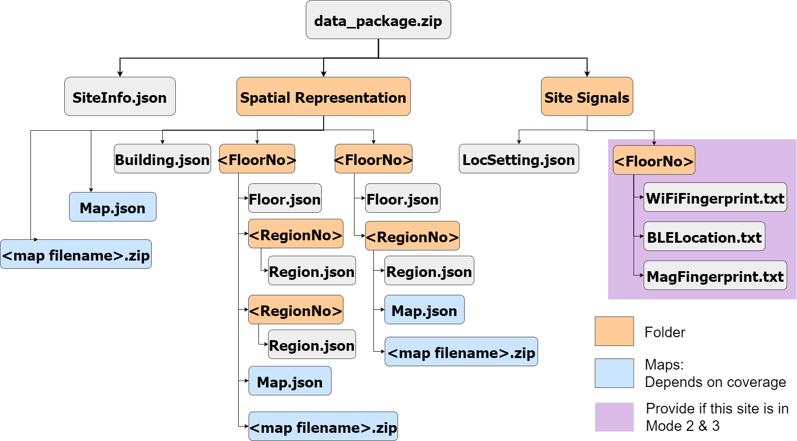

Figure 15a. The file system tree for indoor data validation.

All blocks are named by their filename or folder name. Blocks colored with orange are folders in data package, they named by categories or tags (FloorNo or RegionNo).

Blocks colored with blue are **zipped** map files and metadata of map files, they should be arranged according to map coverage. Details can be found in section 9.2

Blocks colored with purple are site signals file of this building, site owner who wants to share site signal to platform should include this part.

### 9.1.2 Outdoor site data package

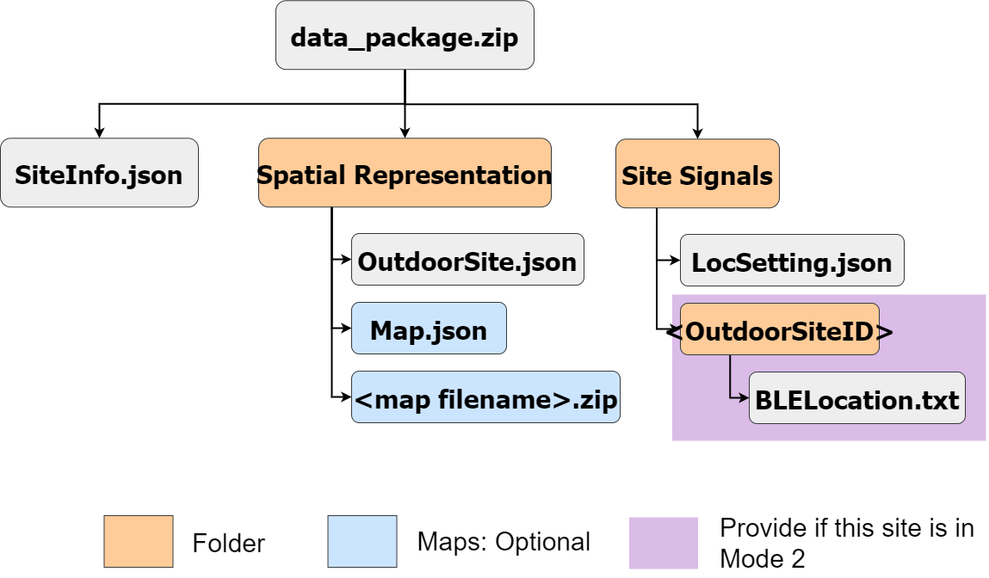

Figure 15b. The file system tree for outdoor data validation.

Outdoor data package contains less information, as outdoor space is less complex. It contains SiteInfo.json, OutdoorSite.json, OutdoorLocSetting.json and some optional data: map.json, map file and outdoor site signals.

Optional map in outdoor data package allow site owner provides customize outdoor map instead of global map on the internet. The map file should be zipped.

Site owner can provide outdoor site signal to platform in operation mode 2 Platform-supported Edge Loc.

## 9.2 Data file specification – Indoor site package

In the top level of the data package, SiteInfo.json, Spatial Representation folder and Site Signals folder will be located at this level.

1. SiteInfo.json

siteInfo.json is a JSON file storing site Information, including site address, site owner information and site owner’s contacts. They should be stored in three fields:

|  |  |  |
| --- | --- | --- |
| Attribute | Data type | Description |
| SiteAddress | String | Postal address of site |
| SiteOwner | String | Site owner description |
| Contacts | String | Email address for contact site owner |
| IndoorSite | Boolean | True if this site is an indoor site, false if it is outdoor site.  For site with semi-outdoor area, site owner should also put it as indoor area. |
|  | | |
| example of SiteInfo.json | {  “SiteAddress”: “HKUST, Clear Waterbay”,  “SiteOwner”: “HKUST”  “Contacts”: “[itsc@ust.hk”](mailto:itsc@ust.hk),  “IndoorSite”:true  } | |

1. Spatial Representation Folder

This folder stores all spatial representations and map files. In this level, Building.json, Floor folders named by their FloorNo and map(optional) are located here.

* 1. Building.json

Building.json should contain all building information, including ID, Name, MapDataID, FloorList and DefaultFloorNo.

|  |  |  |
| --- | --- | --- |
| Attribute | Data type | Description |
| BuildingID | String | The Building Common Spatial Unit Identifier (CSUID) of the building |
| Name | String | Display name of building |
| MapDataID | Array of String(optional) | The array of MapID that are attached in the building, referencing the ID in Map.json specification below.  This map file should cover all floors and regions under this building. |
| FloorList | Array of String | A list of Floor number contained by this building |
| DefaultFloorNo | String | The default floor number of the building to be displayed (e.g., FloorNo hexstring of G/F) |
|  | | |
| Example | {  “BuildingID”: String,  “Name”: String,  “FloorList”: [“FloorNo”],  “DefaultFloorNo”:” FloorNo”,  “MapDataID”: [”MapID”]  } | |

* 1. Floor folder

This folder should be named by FloorNo, containing Floor.json, region folders and map(optional) under this floor.

* + 1. Floor.json

This JSON file contains floor information, including FloorNo, Name, ParentID, RegionList, DefaultRegionNo and MapDataID(optional).

|  |  |  |
| --- | --- | --- |
| Attribute | Data type | Description |
| FloorNo | String | An 8-bit hex string (2 letters) indicating the floor number. Refer to section 6.2 Map Data. |
| Name | String | The display name of the floor excluding the building name |
| MapDataID | Array of String(optional) | The array of MapID that are attached in the floor, referencing the ID in Map.json specification.  This map file should cover all regions under this floor. |
| ParentID | String | ID of parent BuildingID |
| RegionList | Array of String | A list of RegionNo contained by this floor |
| DefaultRegionNo | String | Region number of default region |
|  | | |
| Example | {  “FloorNo”:String,  “Name”:String,  “ParentID”: [“BuildingID”],  “RegionList”: [“RegionNo”],  “DefaultRegionNo”:”RegionNo”,  “MapDataID”:[“MapID”]  } | |

* + 1. Region folder

This folder contains Region.json and map (optional) under this region.

* + - 1. Region.json

This file contains region information, including RegionNo, Name, ConnectedList and MapDataID(optional).

|  |  |  |
| --- | --- | --- |
| Attribute | Data type | Description |
| RegionNo | String | An 8-bit hex string (2 letters) indicating the region number. |
| Name | String | The display name of the region excluding the floor name. |
| MapDataID | Array of String(optional) | The array of MapID that are attached in the region, referencing the ID in Map.json specification. |
| ParentID | String | The parent FloorID, concatenate BuildingID with FloorNo |
| ConnectedRegions | Array of JSON object  {  TransitionArea,  ArrivalArea  } | A list of JSON object that describes the transition areas to other regions and their arrival area of region.  Each data should be arranged as:  {  TransitionArea: Array of double array [lon,lat]  ArrivalArea: Array of JSON {RegionID,Area}  }  JSON {regionID,area} should be arranged as:  {  “RegionID”: connected Region ID,  “Area”: Array of double array [lon,lat]  } |
|  | | |
| Example | {  “RegionNo”: String,  “Name”: String,  “ParentID”:String,  “MapDataID”:[“MapID”],  “ConnectedRegions”:[{  TransitionArea:[ [lon,lat], [lon,lat], [lon,lat], [lon,lat] ],  ArrivalArea: [  {  “RegionID”: String,  “Area”: [ [lon,lat], [lon,lat], [lon,lat], [lon,lat] ]  ]  S}]  } | |

* + 1. Map.json

This JSON file is the metadata of the map file, including MapID, MapFormat, GeodeticPoints, Boundary, AttachedPrimalSpaceID and Filename. This file must be placed at the same level of the spatial object it links to. For example, if this Map.json links to a floor object, it should be placed together with Floor.json.

|  |  |  |
| --- | --- | --- |
| Attribute | Data type | Description |
| MapID | String | ID of map |
| MapFormat | String | The format of the map, e.g., JPG, PNG, IndoorGML, IMDF, etc. |
| GeodeticPoints | Array of JSON object  {X, Y, Lon, Lat} | The array of geodetic points. Each geodetic point contains a coordinate in the map and a [lon,lat] pair. The array contains at least 2 geodetic points.  JSON object of geodetic point is described as:  {  X: Double,  Y: Double,  Lon: Double,  Lat: Double,  } |
| Boundary | Array of Double array [lon,lat] | Array of [lon,lat] points that represent utmost boundary of current Building in the map.  The array contains at least 3 points. |
| AttachedPrimalSpaceID | String | ID of Spatial Object(BuildingID/FloorID/RegionID) that this map links to.  Corresponding JSON object file (Building.json/ Floor.json/ Region.json) should have field ”MapDataID” storing this MapID. |
| Filename | String | Filename of map file |
| Validation | Boolean | Declaimer of map format is valid to the file standard (e.g. IMDF, IndoorGML) |
|  | | |
| Example | {  “MapID”:String,  “MapFormat”:String,  “AttachedPrimalSpaceID ”:String,  “Filename”:String,  “GeodeticPoints”: [  {X, Y, Lon, Lat},  {X, Y, Lon, Lat}  ],  “Boundary”: [  [lon,lat], [lon,lat], [lon,lat],[lon,lat]  ],  “Validation”: true  } | |

* + 1. Map file

This is the zipped map file. It should contain a map file with the same name and format as specified in Map.json and it should be placed together with Map.json. Notice that this zipped map file can be used for multiple buildings, but the Map.json created by site owner to represent current building should be unique to platform.

1. Site Signals Folder

This folder is the entry point of all site signals and their metadata, site signals are arranged according to the floor ID in this folder.

* 1. LocSetting.json

This JSON file stores properties related to localization, including BuildingID, boolean to indicate sharing site signal with platform, SignalMode , CloudLocSignaMode and URLs for distributed server approach.

If site owner wants to share site signal with platform, you should put “True” in ShareSiteSingal and include site signals in the data_package. Otherwise, you should put “false” and provide URLs.

|  |  |  |
| --- | --- | --- |
| Attribute | Data type | Description |
| BuildingID | String | ID of Building, CSUID |
| Boundary | Array of Double array [lon,lat] | Array of [lon,lat] points that represent utmost boundary of current Building in the map.  The array contains at least 3 points. |
| ShareSiteSignal | Boolean | True if site owner shared their site signal with platform. Otherwise, set as false. |
| SiteSignalMode | Array of String  (For ShareSiteSignal == true) | Array of site signal tags to describe available signal for localization.  Mode 0: site server should provide REST API to get available SiteSignalMode  Signal tags: “WiFiFingerprint”, ”BLELocation”, “MagFingerprint” |
| ~~CloudLocSignalMode~~ | ~~Array of String~~  ~~(For Mode 1)~~ | ~~Array of signal tags to describe signal need by cloud localization.~~  ~~Signal tags: “Wifi”, ”BLE”, “Magnetic”~~  Mode 1: site server should provide REST api to get cloudLocSignalMode |
| RemoteSignalDownloadURL | String (only for Mode 0) | URL for downloading site signal package from site server. |
| RemoteCloudLocUploadURL | String (only for Mode 1) | URL for uploading user’s signal to site server for cloud localization. |
| RemoteCloudLocDownloadURL | String (only for Mode 1) | URL for downloading user localization results from the site server. |
|  | | |
| Example | {  “BuildingID”: “CSUID”,  Boundary: [ [lon,lat], [lon,lat], [lon,lat], [lon,lat] ]  “ShareSiteSignal”: False,“RemoteCloudLocUploadURL”: “https://cloudLocUploadURL:port”,  “RemoteCloudLocDownloadURL”: “https://cloudLocDownloadURL:port”  } | |

* 1. Site signal of each floor

Site signals should be arranged according to floor structure, each floor folder is named by FloorNo.

* + 1. WifiFingerprint.txt

This file stores all Wifi fingerprints collected on the floor with FloorNo specified in the upper level. Each row in WifiFingerprint.txt stores one WifiFingerprint on a reference point, it contains Latitude, Longitude, FloorNo and an array of string that stores key-pair of Mac Address and RSSI. The format is:

latitude,longitude,FloorNo|[“mac:rssi”,“mac:rssi”,......,“mac:rssi”]

Notice that separator “|” is used to separate location information and signal information. Spacebar should not appear in the file.

|  |  |
| --- | --- |
| Filename | WifiFingerprint.txt |
| Content | latitude,longitude,FloorNo|[“mac:rssi”,“mac:rssi”,......,“mac:rssi”]  latitude,longitude,FloorNo|[“mac:rssi”,“mac:rssi”,......,“mac:rssi”]  latitude,longitude,FloorNo|[“mac:rssi”,“mac:rssi”,......,“mac:rssi”]  latitude,longitude,FloorNo|[“mac:rssi”,“mac:rssi”,......,“mac:rssi”]  latitude,longitude,FloorNo|[“mac:rssi”,“mac:rssi”,......,“mac:rssi”] |

* + 1. BLELocation.txt

This file stores all beacon identity and its location on the floor with FloorNo specified in the upper level. Each row in file stores one beacon identity, the format is:

latitude,longitude,FloorNo|UUID,major,minor

Notice that separator “|” is used to separate location information and beacon identity. Spacebar should not appear in the file.

|  |  |
| --- | --- |
| Filename | BLELocation.txt |
| Content | latitude,longitude,FloorNo|UUID,major,minor  latitude,longitude,FloorNo|UUID,major,minor  latitude,longitude,FloorNo|UUID,major,minor  latitude,longitude,FloorNo|UUID,major,minor |

* + 1. MagFingerprint.txt

This file stores all magnetic field signal and its location on the floor with FloorNo specified in the upper level. Each row in file stores an array of magnetic field signal on the location, the format is:

latitude,longitude,FloorNo| [”mag_x,mag_y,mag_z”,......,”mag_x,mag_y,mag_z”]

Notice that separator “|” is used to separate location information and beacon identity. Spacebar should not appear in the file.

|  |  |
| --- | --- |
| Filename | MagFingerprint.txt |
| Content | latitude,longitude,FloorNo| [”mag_x,mag_y,mag_z”,......,”mag_x,mag_y,mag_z”]  latitude,longitude,FloorNo| [”mag_x,mag_y,mag_z”,......,”mag_x,mag_y,mag_z”]  latitude,longitude,FloorNo| [”mag_x,mag_y,mag_z”,......,”mag_x,mag_y,mag_z”] |

## 9.3 Data file specification – Outdoor site package

1. SiteInfo.json

siteInfo.json is a JSON file storing site Information, including site address, site owner information and site owner’s contacts. They should be stored in three fields:

|  |  |  |
| --- | --- | --- |
| Attribute | Data type | Description |
| SiteAddress | String | Postal address of site |
| SiteOwner | String | Site owner description |
| Contacts | String | Email address for contact site owner |
| IndoorSite | Boolean | True if this site is an indoor site, false if it is outdoor site.  For site with semi-outdoor area, site owner should also put it as indoor area. |
|  | | |
| example of SiteInfo.json | {  “SiteAddress”: “HKUST, Clear Waterbay”,  “SiteOwner”: “HKUST”  “Contacts”: “[itsc@ust.hk”](mailto:itsc@ust.hk),  “IndoorSite”:false  } | |

1. Spatial Representation Folder

This folder contains spatial information of this outdoor site, including OutdoorSite.json and optional map.json and its mapfile.

* 1. OutdoorSite.json

OutdoorSite.json describes spatial representation of this outdoor site, including outdoor site ID, outdoor site name and boundary of site.

|  |  |  |
| --- | --- | --- |
| Attribute | Data type | Description |
| OutdoorSiteID | String | Outdoor CSUID, it consists of geo-reference number, polygon type and creation date.  Geo-reference number: a 10-digit identifier formed by combining the Easting and Northing of the label point within the outdoor site boundary.  (Easting and Northing are from HK 1980 Grid Coordinates, decimal is truncated and the first digit is removed from the coordinates.)  Polygon type: ‘O’ for Outdoor.  Creation Date: YYYYMMDD  e.g. OutdoorSiteID: “4520522021O20220412” |
| OutdoorSiteName | String | Outdoor site name |
| Boundary | Array of double array [lon,lat] | Array of [lon,lat] points that represent utmost boundary of outdoor site.  The array contains at least 3 points. |
| MapDataID | String | Optional map ID of Map.json |
|  | | |
| example of OutdoorSite.json | {  “OutdoorSiteID”:” 4520522021O20220412”,  “OutdoorSiteName”:” HKSTP phase 3 outdoor”,  “Boundary”: [  [lon,lat], [lon,lat], [lon,lat], [lon,lat]  ]  } | |

* 1. Map.json

This JSON file is the metadata of the map file, including MapID, MapFormat, GeodeticPoints, Boundary, AttachedPrimalSpaceID and Filename.

|  |  |  |
| --- | --- | --- |
| Attribute | Data type | Description |
| MapID | String | ID of map |
| MapFormat | String | The format of the map, e.g., JPG, PNG, IndoorGML, IMDF, etc. |
| GeodeticPoints | Array of JSON object  {X, Y, Lon, Lat} | The array of geodetic points. Each geodetic point contains a coordinate in the map and a [lon,lat] pair. The array contains at least 2 geodetic points.  JSON object of geodetic point is described as:  {  X: Double,  Y: Double,  Lon: Double,  Lat: Double,  } |
| Boundary | Array of double array [lon,lat] | Array of [lon,lat] points that represent utmost boundary of current site on the map.  The array contains at least 3 points. |
| AttachedPrimalSpaceID | String | ID of outdoor site that this map links to.  Corresponding OutdoorSite.json should have field ”MapDataID” storing this MapID. |
| Filename | String | Filename of map file |
| Validation | Boolean | Declaimer of map format is valid to the file standard (e.g. IMDF, IndoorGML) |
|  | | |
| Example | {  “MapID”:String,  “MapFormat”:String,  “AttachedPrimalSpaceID ”:String,  “Filename”:String,  “GeodeticPoints”: [  {X, Y, Lon, Lat},  {X, Y, Lon, Lat}  ],  “Boundary”: [  [lon,lat], [lon,lat], [lon,lat], [lon,lat]  ],  “Validation”: true  } | |

* 1. Mapfile

This is the zipped map file. It should contain a map file with the same name and format as specified in Map.json and it should be placed together with Map.json. Notice that map file may contain multiple site, but the Map.json created by site owner to represent current outdoor site should be unique to platform.

1. Site Signal Folder
   1. LocSetting.json

This JSON file stores properties related to localization, including OutdoorSiteID, boolean indicate sharing site signal with platform, SignalMode and URLs for distributed server approach.

If site owner wants to share site signal with platform, you should put “True” in ShareSiteSingal and include site signals in the data_package. Otherwise, you should provide download site signal URL.

|  |  |  |
| --- | --- | --- |
| Attribute | Data type | Description |
| OutdoorSiteID | String | ID of Outdoor site |
| Boundary | Array of Double array [lon,lat] | Array of [lon,lat] points that represent utmost boundary of current Building in the map.  The array contains at least 3 points. |
| ShareSiteSignal | Boolean | True if site owner shared their site signal with platform. Otherwise, set as false. |
| SiteSignalMode | Array of String  (For Mode 2) | Array of site signal tags to describe available signal for localization.  Mode 0: site server should provide REST API to get available SiteSignalMode  Signal tags: ”BLELocation” |
| RemoteSignalDownloadURL | String (only for Mode 0) | URL for downloading site signal package from site server. |
|  | | |
| Example | {  “OutdoorSiteID”: String,  “Boundary”: [ [lon,lat], [lon,lat], [lon,lat], [lon,lat] ]  “ShareSiteSignal”: false,“RemoteSignalDownloadURL”: “<https://RemoteSignalDownloadURL>:port”  } | |

* 1. <OutdoorSiteID> Folder
     1. BLELocation.txt

This file stores all beacon identity and its location on the outdoor site. Each row in file stores one beacon identity, the format is:

latitude,longitude,OutdoorSiteID|UUID,major,minor

Notice that separator “|” is used to separate location information and beacon identity. Spacebar should not appear in the file.

|  |  |
| --- | --- |
| Filename | BLELocation.txt |
| Content | latitude,longitude, OutdoorSiteID |UUID,major,minor  latitude,longitude, OutdoorSiteID |UUID,major,minor  latitude,longitude, OutdoorSiteID |UUID,major,minor  latitude,longitude, OutdoorSiteID |UUID,major,minor |

## 9.4 Data validation on the platform

When the data package is uploaded by the site owner, it will pass through a validation process by the platform operator to check if it conforms to the standard. If it passes the validation, it will be managed and recorded into the database for web API requests. Otherwise, the platform operator will contact the site owner through email to revise their data package.

The data validation tool operates on the platform only checks the file structure, data format and necessary information for communication, data accuracy inside the data file will not be checked. For example, the existence of field name “BuildingName'' will be checked in file B*uilding.json*, but the value of “BuildingName” : “dummy building” will not be checked. Site owners and developers should be aware of the data accuracy.

# 10 User Journey Examples

10.1 Setting

This setting is used throughout this section:

There are two buildings, namely building A and building B, and the first floor of building A and B are connected by a skyway.

Building A’s site owner is not willing to share his site signals with the lookup server while building B’s site owner is. Building A’s site owner hosts a server for computing location and a server for downloading site signals, he sends his server addresses and maps to the lookup server. Buidling B’s site owner sends his site signals and maps to the lookup server.

Building A’s site signals are iBeacon locations while building B’s site signals are WIFI fingerprints.

Application uses reference designs in SDK by default.

10.2 Operation Mode

Operation Mode 0

Say the user is in building A, and the application is initializing a location.

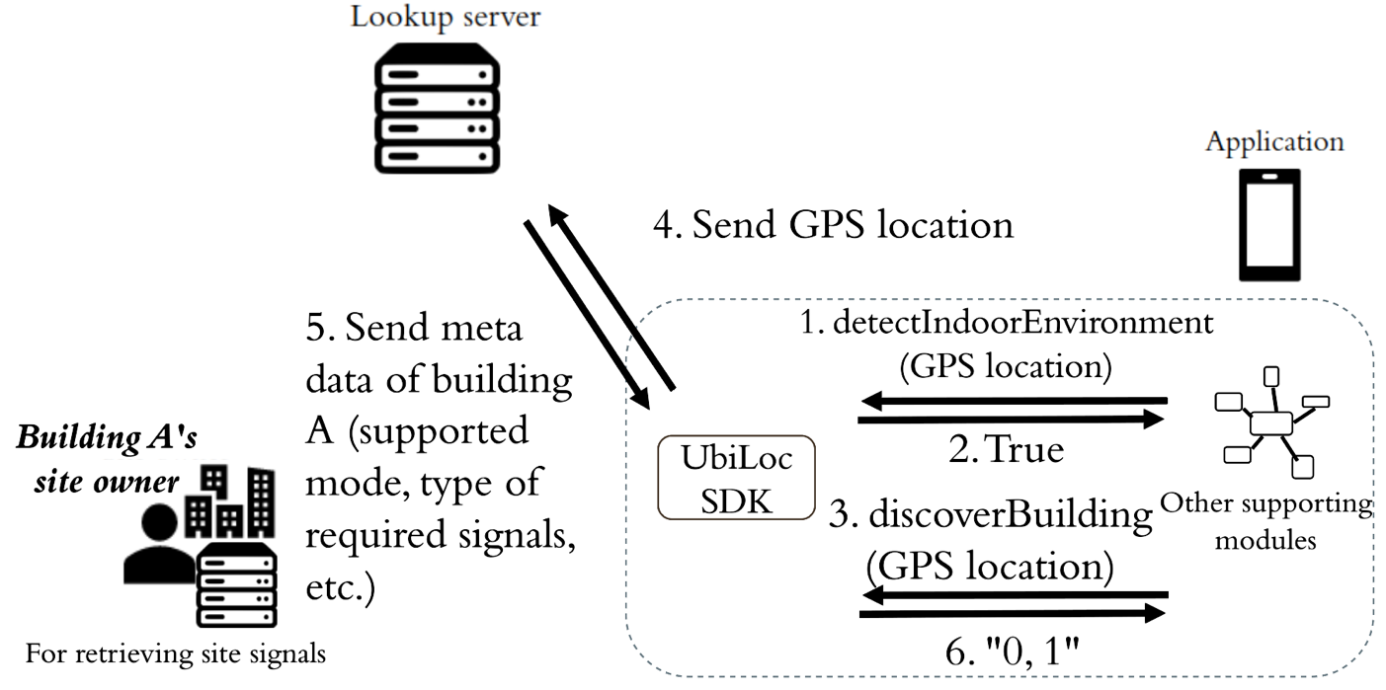

Figure 16. Detecting indoor environment and handshaking for operation mode of building A

First, the application initiates a Localization Asistant and an API Manager using the SDK, and call the detectIndoorEnvironment() in Localization Asistant by inputting the location result from GPS. It should return true since the user is inside the building.

Then call the discoverBuilding() in API Manager by inputting the location result from GPS. The API Manager then contacts the lookup server to find the nearest building of the given location which is building A in this case, and returns the supported modes of building A. The result should be “0, 1” since building A supports both operation mode 0 and 1.

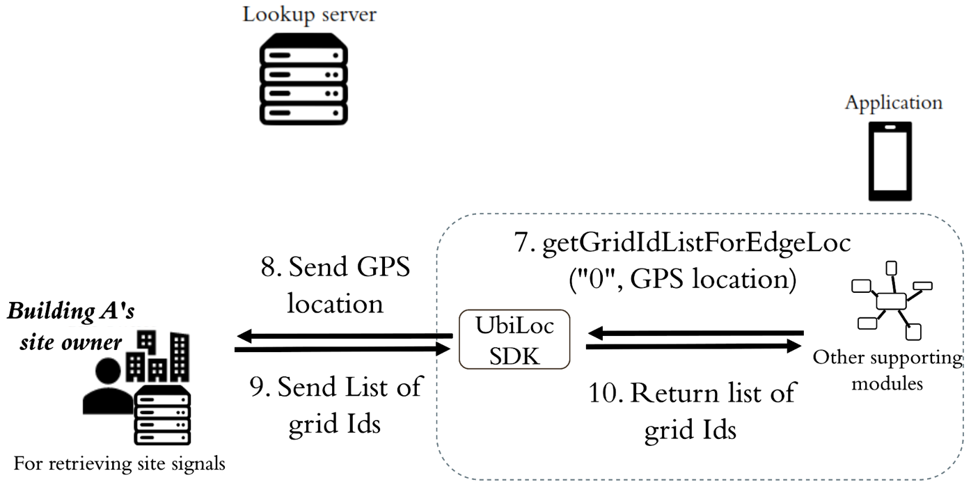

Figure 17. Requesting grid Ids from the site owner’s server

Then the application calls the getGridIdListForEdgeLoc() in the API Manager to get the grid Ids of grids that are close to the GPS location from the site owner’s server.

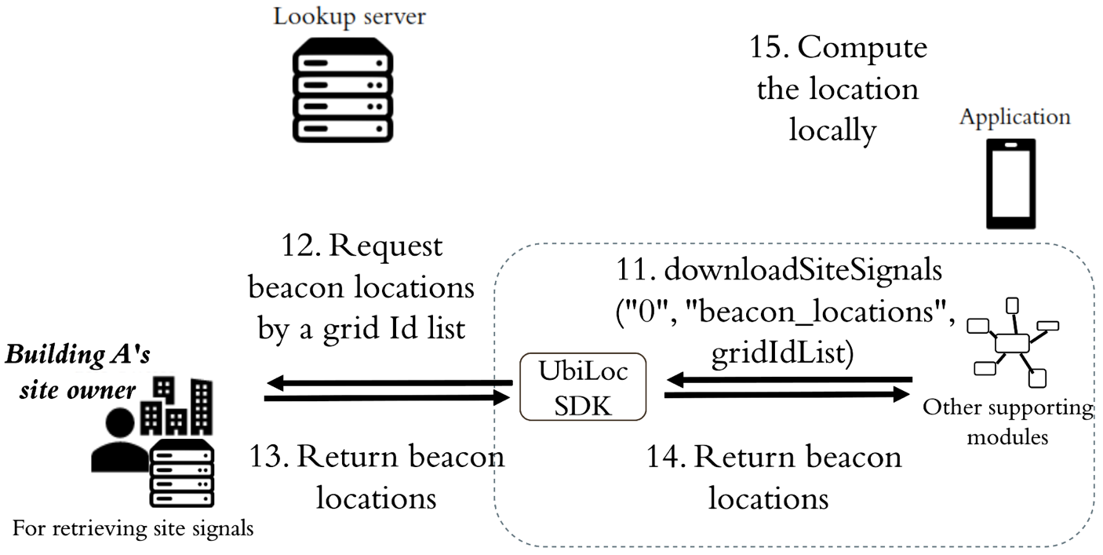

Figure 18. Requesting grids from the site owner’s server and computing location locally

Since the application chooses mode 0 which is an edge approach, the application calls the downloadSiteSignals() in the API Manager to download the site signals that are the beacon locations in this case from the site owner’s server. The location is then computed locally using those downloaded beacon locations.

In every location computation, the application first checks if the downloaded beacon locations can be used to provide a valid location. If not, meaning that the user moves away from the region covered by the downloaded beacon locations, then new beacon locations need to be downloaded by handshaking again or manipulating the grid Id list and requesting again for advanced developers.

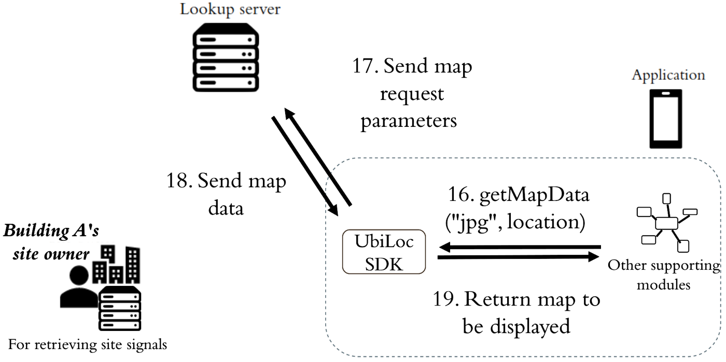

Figure 19. Requesting maps from the lookup server

With the location, the application calls the getMapData() in the API Manager to obtain the map in its preferred format, .jpg in this case, from the lookup server.

Operation Mode 1

Say the user is in building A, and the application is initializing a location.

Steps 1 – 6 are the same as operation mode 0 to confirm the building and the operation mode.

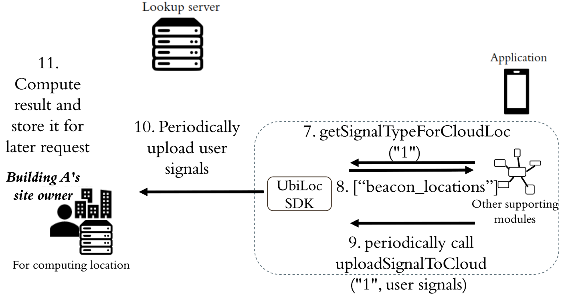

Figure 20. Confirming required signal types from and uploading user signals to the site owner’s server

Since the application chooses mode 1 which is a cloud approach, it needs to know what signals are supposed to be uploaded by calling the getSignalTypeForCloudLoc() in API Manager. The result should be [“beacon_locations”]. Next is to periodically, say 10s, collect the beacon signals and call the uploadSignalToCloud() in the API Manager. After receiving the user signals, building A’s server needs to compute and store the result for future location requests.

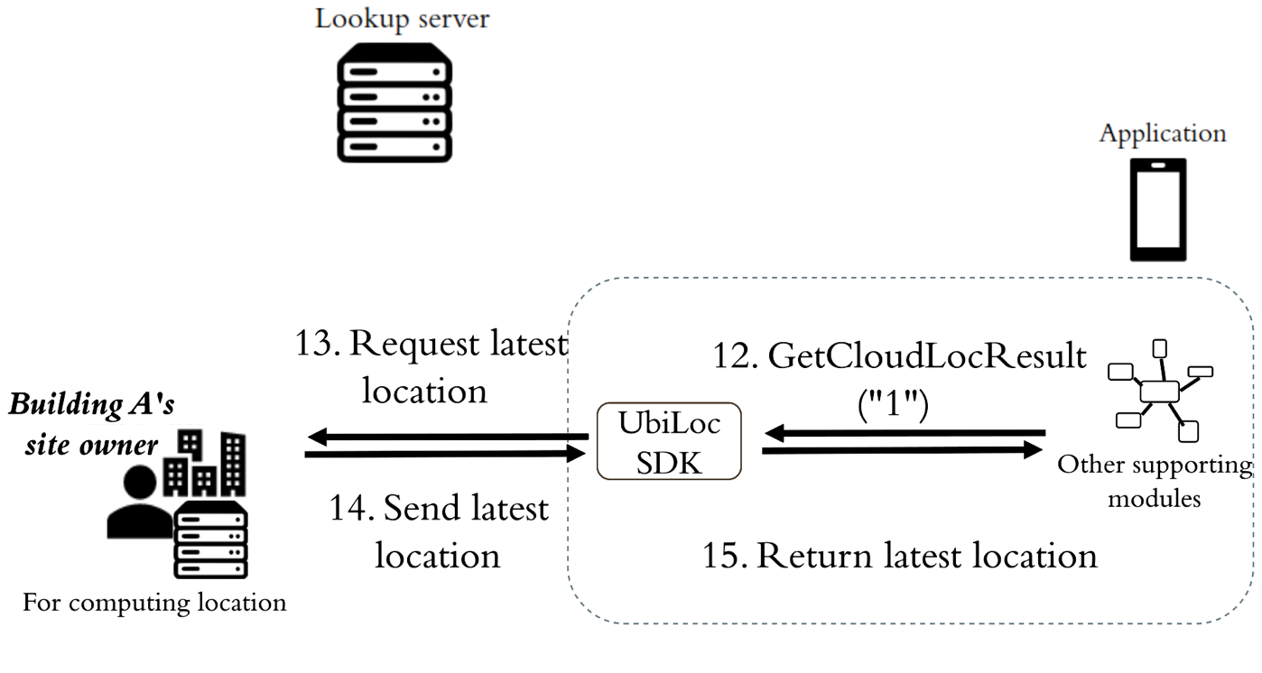

Figure 21. Requesting latest location from the site owner’s server

The application then calls the getCloudLocResult() in the API Manager to retrieve the location from the site owner’s server, and the server returns the latest location of this user.

With the location, the application calls the getMapData() in the API Manager to obtain the map from the lookup server, similar to operation mode 0.

Operation Mode 2

Say the user is in building B, and the application is initializing a location.

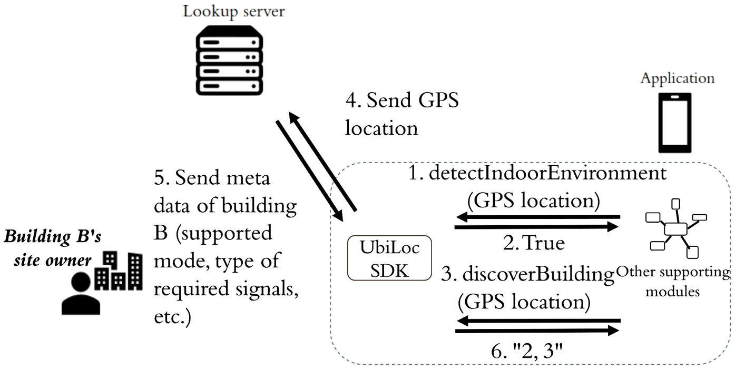

Figure 22. Detecting indoor environment and handshaking for operation mode of building B

First, the application initiates a Localization Asistant and an API Manager using the SDK, and call the detectIndoorEnvironment() in Localization Asistant by inputting the location result from GPS. It should return true since the user is inside the building.

Then call the discoverBuilding() in API Manager by inputting the location result from GPS. The API Manager then contacts the lookup server to find the nearest building of the given location which is building B in this case, and returns the supported modes of building B. The result should be “2, 3” since building B supports both operation mode 2 and 3.

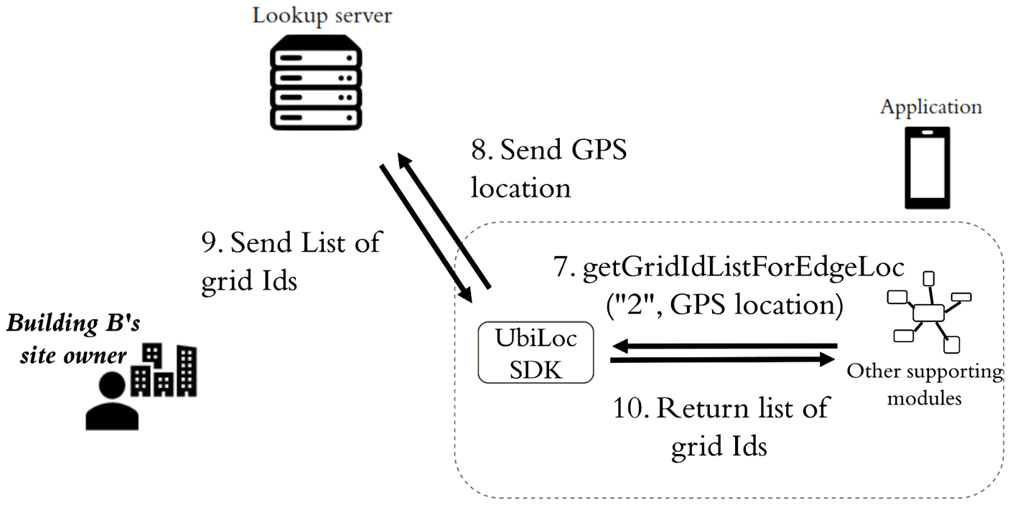

Figure 23. Requesting grid Ids from the lookup server

Then the application calls the getGridIdListForEdgeLoc() in the API Manager to get the grid Ids of grids that are close to the GPS location from the lookup server.

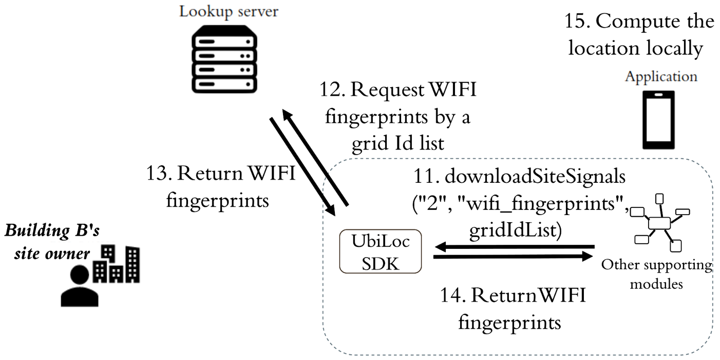

Figure 24. Requesting grids from the lookup server and computing location locally

Since the application chooses mode 2 which is an edge approach, the application calls the downloadSiteSignals() in the API Manager to download the site signals that are the WIFI fingerprints in this case from the lookup server. The location is then computed locally using those downloaded fingerprints.

In every location computation, the application first checks if the downloaded fingerprints can be used to provide a valid location. If not, meaning that the user moves away from the region covered by the downloaded fingerprints, then new fingerprints need to be downloaded by handshaking again or manipulating the grid Id list and requesting again for advanced developers.

With the location, the application calls the getMapData() in the API Manager to obtain the map from the lookup server, similar to other operation modes.

Operation Mode 3

Say the user is in building B, and the application is initializing a location.

Step 1 – 6 are the same as operation mode 2 to confirm the building and the operation mode.

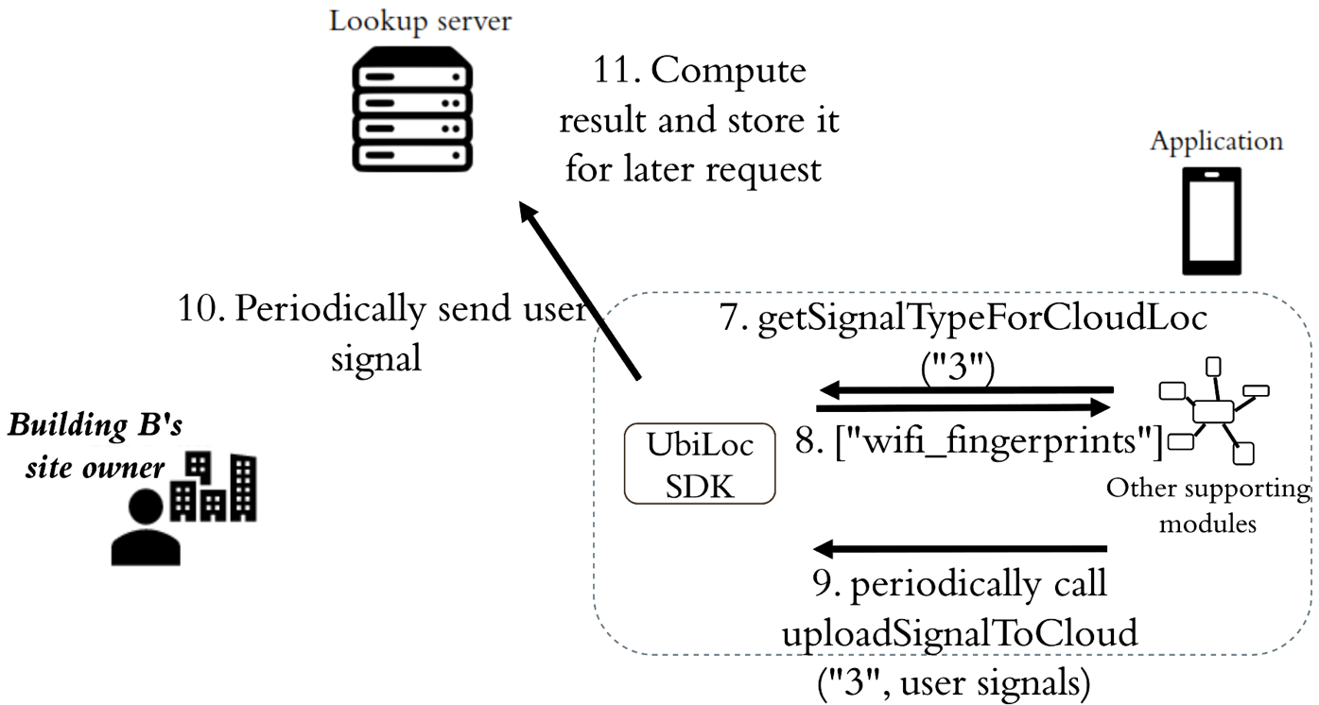

Figure 25. Confirming required signal types from and uploading user signals to the lookup server

Since the application chooses mode 3 which is a cloud approach, it needs to know what signals are supposed to be uploaded by calling the getSignalTypeForCloudLoc() in API Manager. The result should be [“wifi_fingerprints”]. Next is to periodically, say 10s, collect the WIFI user signals and call the uploadSignalToCloud() in the API Manager. After receiving the user signals, the lookup server needs to compute and store the result for future location requests.

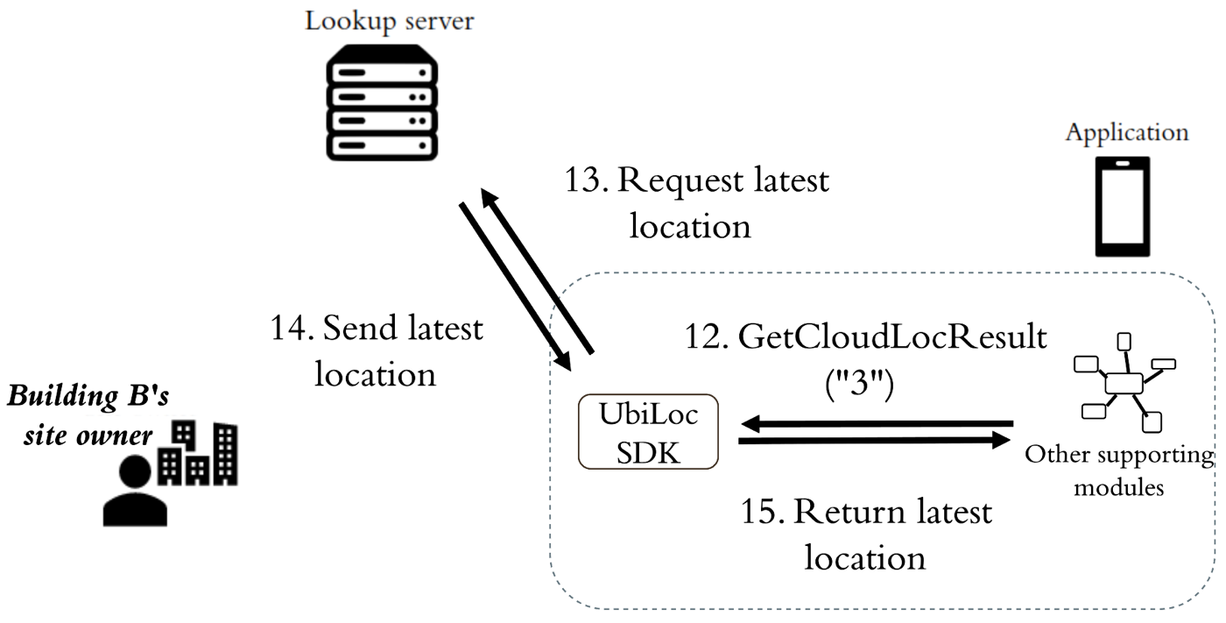

Figure 26. Requesting latest location from the lookup server

The application then calls the getCloudLocResult() in the API Manager to retrieve the location from the lookup server, and the server returns the latest location of this user.

## 10.3 Switching Floor and Mode

Switching Floor

In cloud approaches, switching floor does not require application developers to initiate. Since the location computations are in the site owner’s server (mode 1 in building A) or the lookup server (mode 3 in building B), they are responsible for detecting if the user enters a new floor and returning the correct location result. Application developers only need to check if the floorId is different from the previous one, indicating new map needs to be downloaded.

In edge approaches, application developers are responsible for detecting if the user enters a new floor. With the downloaded beacon locations (building A) or fingerprints (building B), the application can detect if the user is in the supported region of the downloaded signals, using the location result and the grid information of the downloaded grids. If the user is in the boundary grids or outside the grids, the application should load new site signals, and the simplest way is to handshake again. More advanced developers may want to manipulate with the grid Ids by their understanding of the data format designs, e.g., BuildingObj, FloorObj, GridObj, etc. and retrieve the suitable grids from the site owner’s server (mode 0 in building A) and the lookup server (mode 2 in building B).

Switching Mode

Switching mode is rather straightforward. The application should periodically call the detectSwitchCondition() in the Localization Asistant. Say the user is moving from building A to building B. The detectSwitchCondition() should return building B’s Id at some point. When this happens, the application can handshake again with the lookup server, and steps 1-6 in operation mode 2/3 in the previous section should be processed to locate the user in building B with a minor difference that the application calls the discoverBuilding() with the building B’s Id instead of the GPS location.

## 10.4 Outdoor Localization

Say the application is initializing a location outside building A and B. The application first calls the detectIndoorEnvironment() in the Localization Asistant, and the result should be false. The application can then use GPS result directly or call its outdoor localization algorithm with the outdoor signals, for example, the smart lampposts. The application calls the getOutdoorSignal() in the API Manager, and, in this case, it returns an empty array since no outdoor signals are available. Therefore, the application uses the GPS result directly.

10.5 In-Outdoor Transition

Indoor to Outdoor

This is similar to switching mode. Say the user is moving from building B to outdoors. The detectSwitchCondition() should return “outdoor” at some point. When this happens, the application switches to outdoor localization like in section 10.4.

Outdoor to Indoor

When the application is in outdoor environments, it should call detectIndoorEnvironment() periodically. Say the user enters building B. The detectIndoorEnvironment() should return true at some point. When this happens, steps 1-6 in operation mode 2/3 in the previous section are processed to locate the user in building B.

# Bibliography

[1] OGC, OGC City Geography Markup Language (CityGML) Encoding Standard version 2.0, OGC 12-019, 2012

[2] OGC, OGC KML version 2.3, OGC 12-007r2, 2015

[3] OGC, OGC IndoorGML version 1.0.3, OGC 14-005r5, 2018

[4] OGC, OGC IMDF version 1.0.0, OGC 20-094, 2021

[5] International Organization for Standardization. (2016). Information technology — Real time locating systems — Test and evaluation of localization and tracking systems (ISO/IEC 18305:2016). Retrieved from <https://www.iso.org/standard/62090.html>

[6] International Organization for Standardization. (2019). Geographic information — Positioning services (ISO 19116:2019). Retrieved from <https://www.iso.org/standard/70882.html>

[7] K. -J. Li, S. Zlatanova, J. Torres-Sospedra, A. Perez-Navarro, C. Laoudias and A. Moreira, "Survey on Indoor Map Standards and Formats," 2019 International Conference on Indoor Positioning and Indoor Navigation (IPIN), 2019, pp. 1-8, doi: 10.1109/IPIN.2019.8911796.

[8] Anonymous, Tilesets: Google maps structure - MicroImages, Inc. [Online]. Available: https://www.microimages.com/documentation/TechGuides/78googleMapsStruc.pdf.

[9] Yan, Jinjin. (2020). Seamless Navigation in Indoor and Outdoor based on 3D Spaces. PhD thesis, UNSW Sydney, Sydney

[10] Löwner, M., Gröger, G., Benner, J., Biljecki, F., & Nagel, C. (2016). PROPOSAL FOR A NEW LOD AND MULTI-REPRESENTATION CONCEPT FOR CITYGML. ISPRS Annals of the Photogrammetry, Remote Sensing and Spatial Information Sciences, IV-2/W1, 3-12.

[11] Kutzner, T., Chaturvedi, K., & Kolbe, T. (2020). CityGML 3.0: New Functions Open Up New Applications. Journal of Photogrammetry, Remote Sensing and Geoinformation Science, 88(1), 43-61.

[12] Liu, L., Li, B., Zlatanova, S., & Van Oosterom, P. (2021). Indoor navigation supported by the Industry Foundation Classes (IFC): A survey. Automation in Construction, 121, Automation in construction, 2021-01, Vol.121.

[13] Cantarero Navarro, R., Rubio Ruiz, A., Dorado Chaparro, J., Villanueva Molina, F., Santofimia Romero, M., Villa Alises, D., & Lopez Lopez, J. (2020). A Proposal for Modeling Indoor–Outdoor Spaces through IndoorGML, Open Location Code and OpenStreetMap. ISPRS International Journal of Geo-information, 9(3), 169.

[14] Gilbert, T., Rönsdorf, C., Plume, J., Simmons, S., Nisbet, N., Gruler, H., Kolbe, T.H., Berlo, L.V., & Mercer, A. (2020). Built environment data standards and their integration: an analysis of IFC, CityGML and LandInfra.

[15] Jones, M., Bradley, J., and N. Sakimura, "JSON Web Token (JWT)", RFC 7519, DOI 10.17487/RFC7519, May 2015, <https://www.rfc-editor.org/info/rfc7519>.

# Revision History

|  |  |  |  |  |
| --- | --- | --- | --- | --- |
| Date | Release | Authors | Paragraph modified | Description |
| Apr. 06, 2022 | v.0.1 | Gary W.-H. Cheung,  Peter Tsui,  Mengyun Liu,  S.-H. Gary Chan |  | First draft |